© 2020 Little Owls Resources

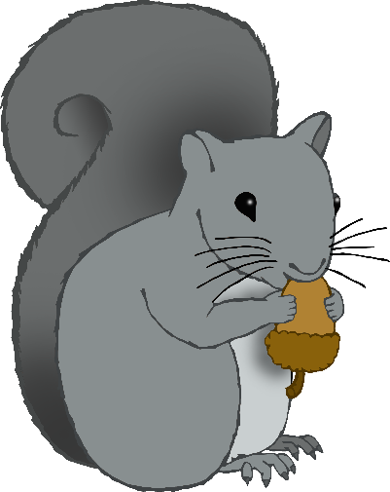

Can you make the right number of acorns for the squirrel?

**1**

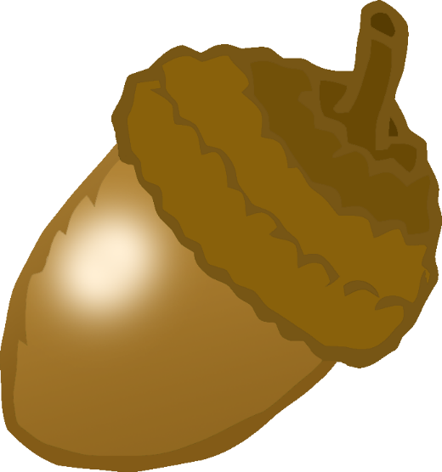

© 2020 Little Owls Resources



Can you make the right number of acorns for the squirrel?

**2**

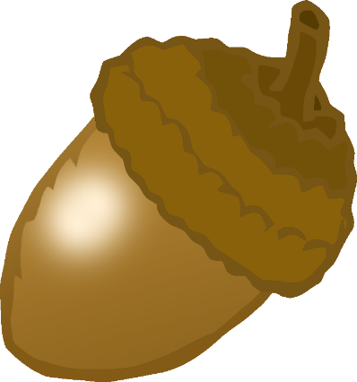

© 2020 Little Owls Resources



Can you make the right number of acorns for the squirrel?

**3**



© 2020 Little Owls Resources



Can you make the right number of acorns for the squirrel?

**4**

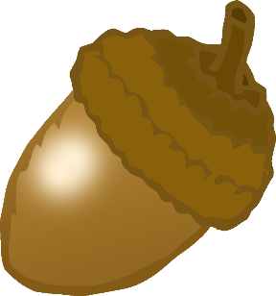

© 2020 Little Owls Resources



Can you make the right number of acorns for the squirrel?

**5**



© 2020 Little Owls Resources



Can you make the right number of acorns for the squirrel?

**6**

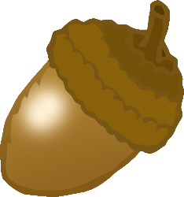

© 2020 Little Owls Resources



Can you make the right number of acorns for the squirrel?

**7**

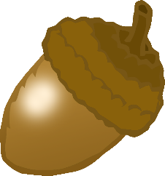

© 2020 Little Owls Resources



Can you make the right number of acorns for the squirrel?

**8**

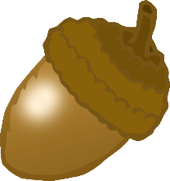

© 2020 Little Owls Resources



Can you make the right number of acorns for the squirrel?

**9**

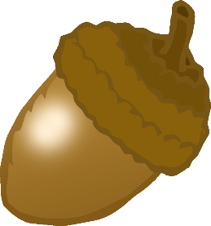

© 2020 Little Owls Resources



Can you make the right number of acorns for the squirrel?

**10**

