\*2-4 Players

\*Dice required

\*Will work best with all resources laminated.

* Each player chooses a coloured token (below) and places it on Start. Gather an ‘Acorn Tray’ (p6) ready for game.
* Youngest player rolls dice first. Move token clockwise around the edge.
* Land on an acorn (or acorns) gather corresponding number of acorn tokens (p7).
* Land on a fox…lose all your acorns!
* When a player gathers ten acorns they stop moving around the edge and turns inwards to the tree.
* First player to get to the tree wins!

Squirrel Dash Game

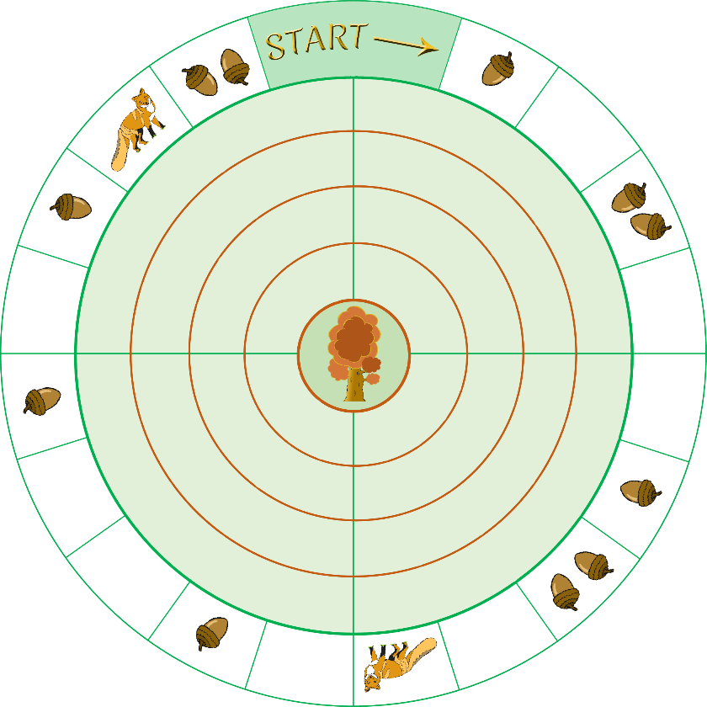

www.littleowls-premium.com

