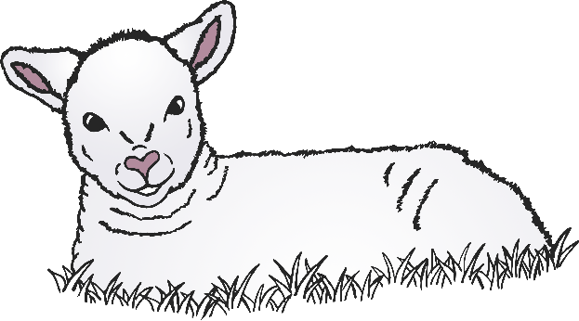

swallow

lamb

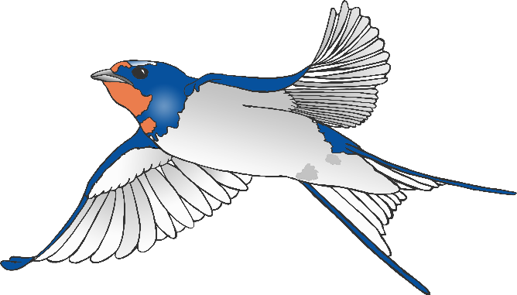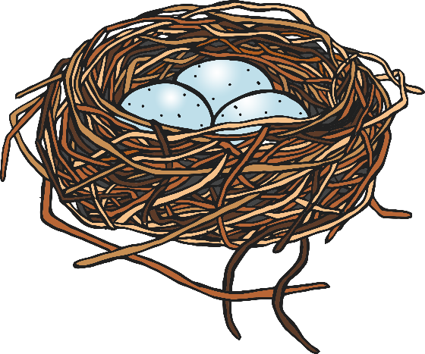

© 2021 Little Owls Resources

© 2021 Little Owls Resources

bird nest

© 2021 Little Owls Resources

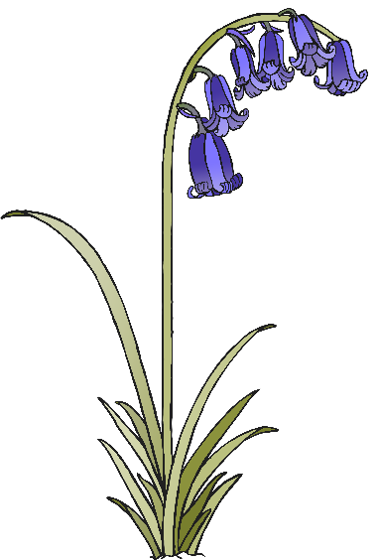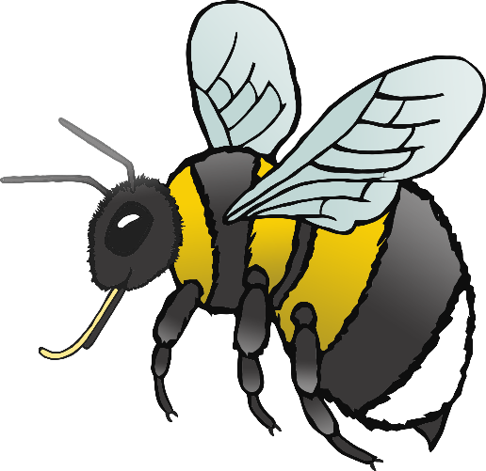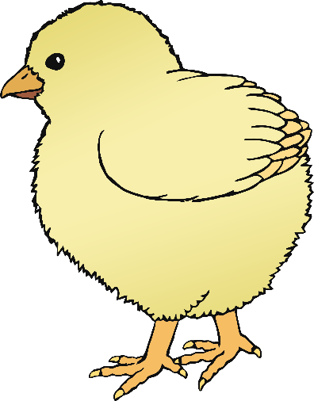

bluebells

bee

chick

© 2021 Little Owls Resources

© 2021 Little Owls Resources

© 2021 Little Owls Resources

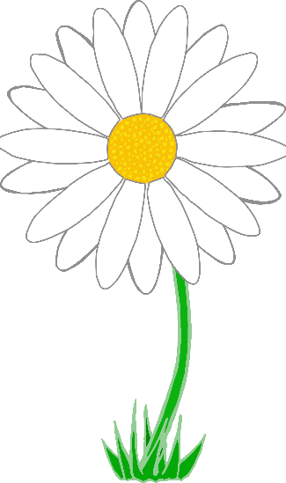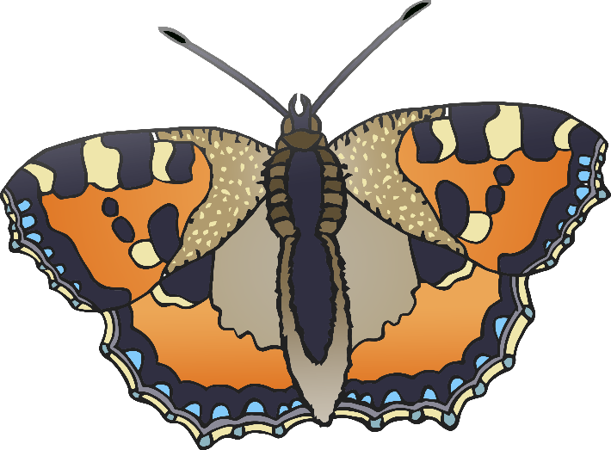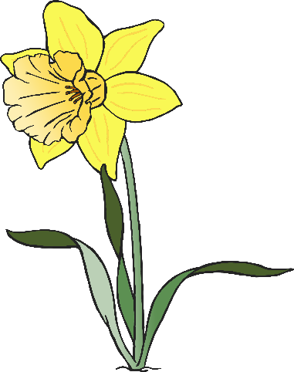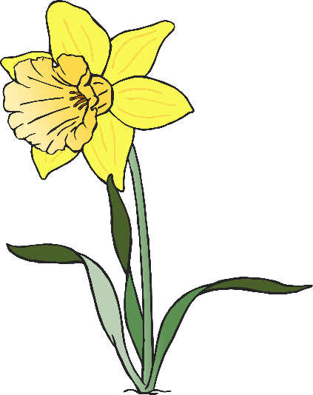

daffodils

butterfly

daisy

© 2021 Little Owls Resources

© 2021 Little Owls Resources

© 2021 Little Owls Resources

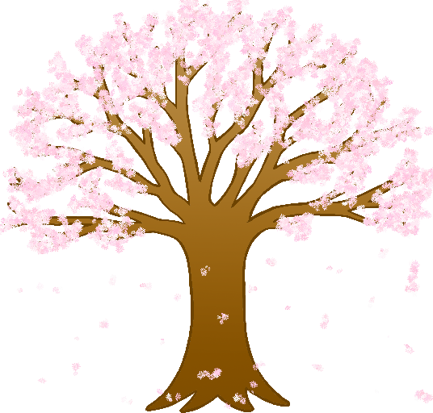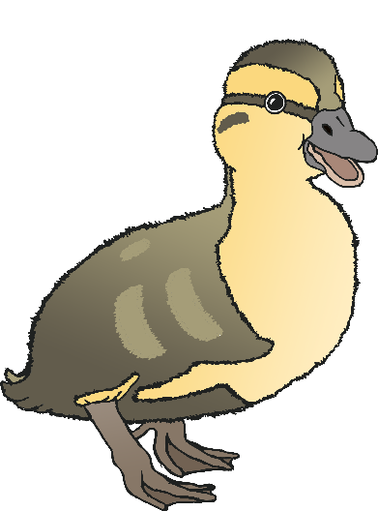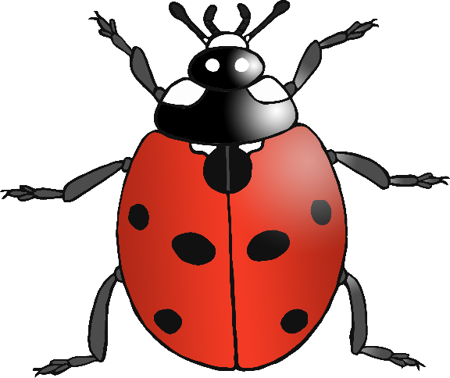

ladybird

duckling

blossom

© 2021 Little Owls Resources

© 2021 Little Owls Resources

© 2021 Little Owls Resources