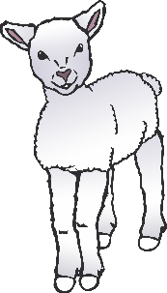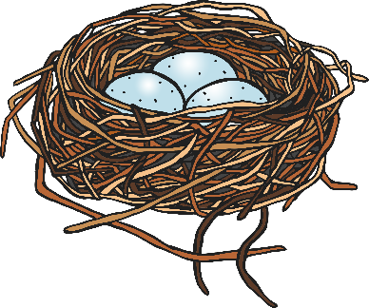

**Spring Word Mat**

© 2023 Little Owls Resources

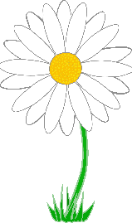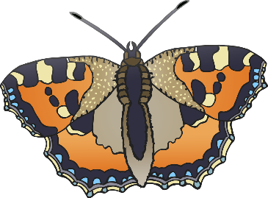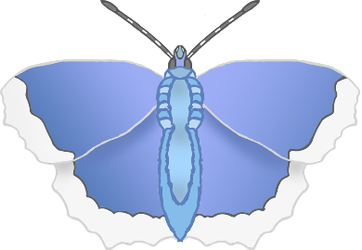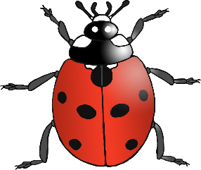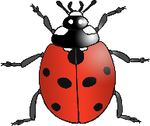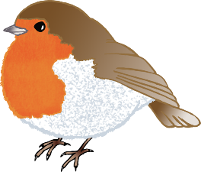

baby animals

trees

butterflies

sun

bees

birds

blossom

flowers

ladybirds

rain

leaves

green