**Spring Senses Prompts**

daisy

These prompts are intended to encourage discussion and thinking about our senses during the spring.

Together with each mini-banner there are small note sheets for children to mark-make/write/draw their thoughts and experiences.

© 2022 Little Owls Resources

© 2020 Little Owls Resources

© 2022 Little Owls Resources

What can you smell?

**Senses**

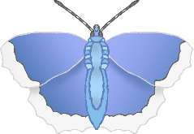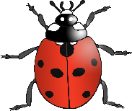

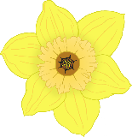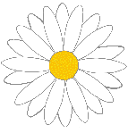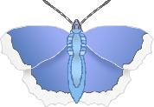

© 2022 Little Owls Resources

I smell…

© 2022 Little Owls Resources

I smell…

**Spring**

© 2022 Little Owls Resources

I smell…

© 2022 Little Owls Resources

I smell…



© 2022 Little Owls Resources

I smell…

© 2022 Little Owls Resources

I smell…



© 2022 Little Owls Resources

What can you see?

**Senses**



© 2022 Little Owls Resources

I see…

© 2022 Little Owls Resources

I see…

**Spring**

© 2022 Little Owls Resources

I see…

© 2022 Little Owls Resources

I see…



© 2022 Little Owls Resources

I see…

© 2022 Little Owls Resources

I see…



© 2022 Little Owls Resources

What can you hear?

**Senses**



© 2022 Little Owls Resources

I hear…

© 2022 Little Owls Resources

I hear…

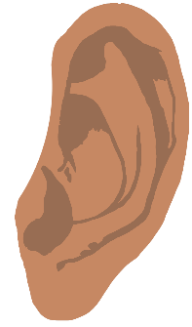

**Spring**

© 2022 Little Owls Resources

I hear…

© 2022 Little Owls Resources

I hear…



© 2022 Little Owls Resources

I hear…

© 2022 Little Owls Resources

I hear…



© 2022 Little Owls Resources

What can you feel?

**Senses**



© 2022 Little Owls Resources

I feel…

© 2022 Little Owls Resources

I feel…

**Spring**

© 2022 Little Owls Resources

I feel…

© 2022 Little Owls Resources

I feel…

© 2022 Little Owls Resources

I feel…

© 2022 Little Owls Resources

I feel…



© 2022 Little Owls Resources

What can you taste?

**Senses**



© 2022 Little Owls Resources

I taste…

© 2022 Little Owls Resources

I taste…

**Spring**



© 2022 Little Owls Resources

I taste…

© 2022 Little Owls Resources

I taste…



© 2022 Little Owls Resources

I taste…

© 2022 Little Owls Resources

I taste…