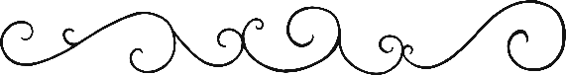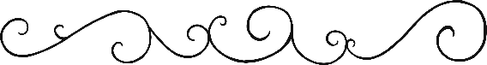

1

99

8

7

6

5

1

4

3

2

**Spring Number Formation Mat**

© 2020 Little Owls Resources

**Spring Number Formation Mat**

1

99

8

7

6

5

1

4

3

2

© 2020 Little Owls Resources

1