**Decorate a Spring Leaf!**

© 2021 Little Owls Resources

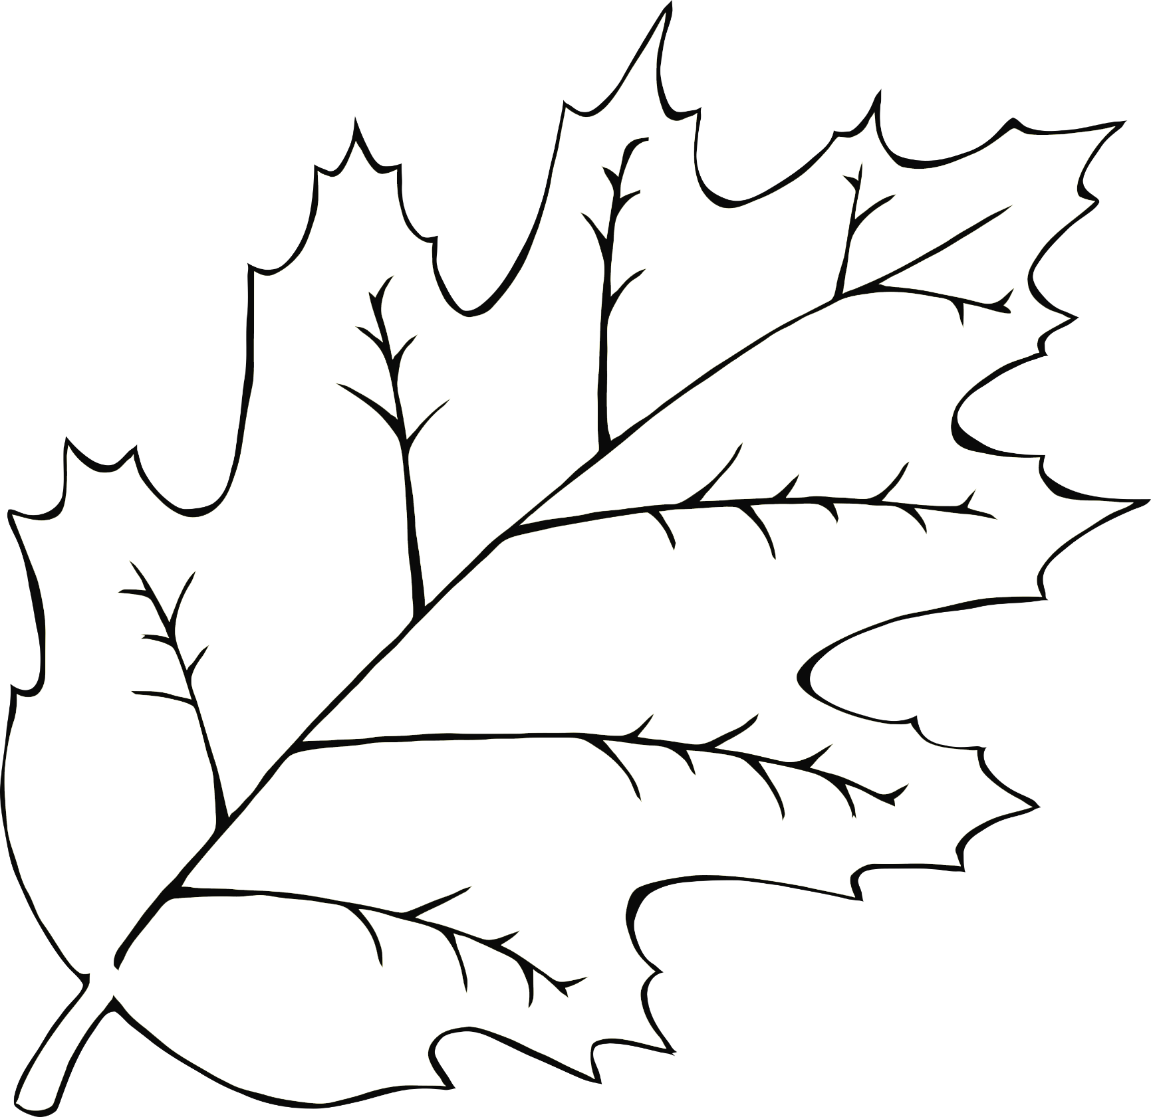

**Decorate a Spring Leaf!**

© 2021 Little Owls Resources

**Decorate a Spring Leaf!**

© 2021 Little Owls Resources



**Decorate a Spring Leaf!**

© 2021 Little Owls Resources

