Spring Activity

Challenge!

1

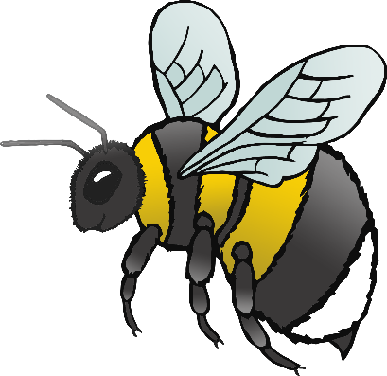

Fly around like a buzzing bee!

Buzz! Buzz!

Spring Activity

Challenge!

2

Float through the air like blossom falling from a tree.

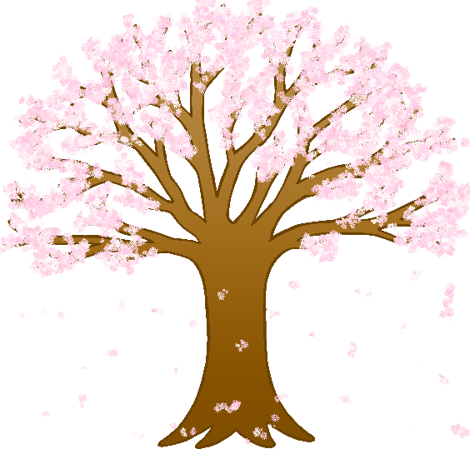

Spring Activity

Challenge!

3

Jump around like a baby lamb!

Jump! Jump!

Spring Activity

Challenge!

4

Scratch the floor with your foot like a chick.

Scratch! Scratch!

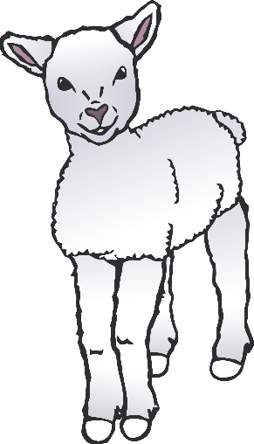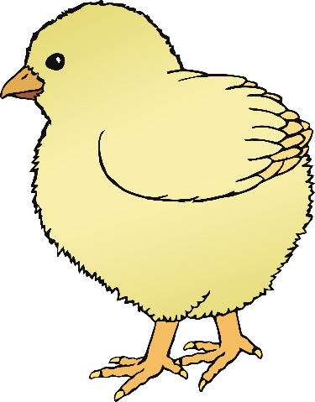

Spring Activity

Challenge!

5

Fly as quietly as you can… like a butterfly!

Spring Activity

Challenge!

6

Waddle in a group with your friends… like ducklings!

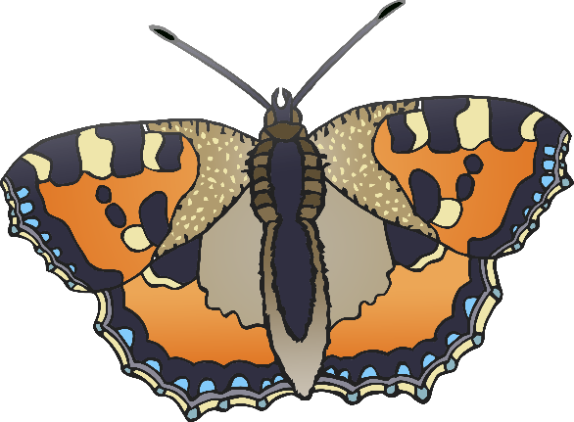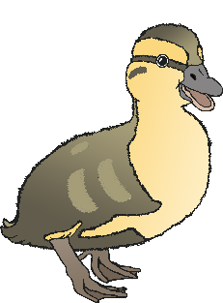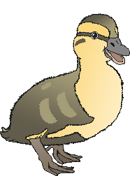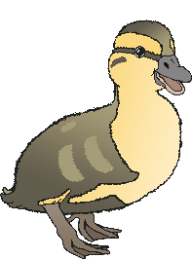

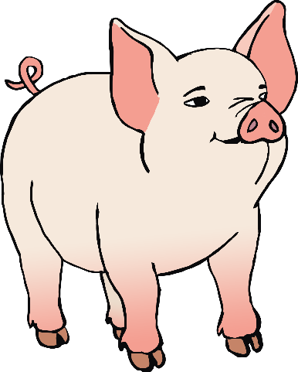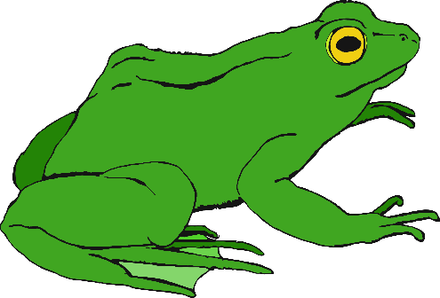

Spring Activity

Challenge!

7

Oink like a piglet!

Oink! Oink!

Spring Activity

Challenge!

8

Splash into the pond and swim like a frog!

Hop! Splash!