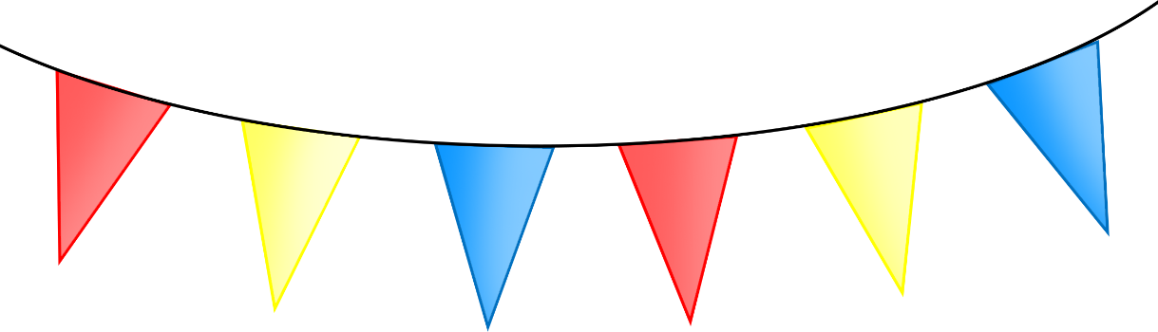

© 2023 Little Owls Resources

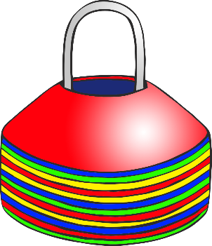

We need

your help!

Date:

**Sports Day!**

© 2023 Little Owls Resources

Date:

We need your help!

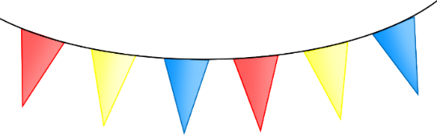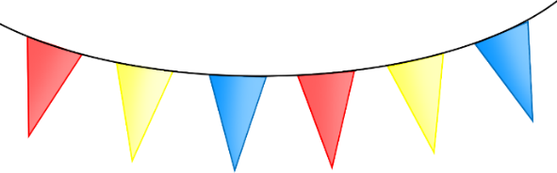

**Sports Day!**



© 2023 Little Owls Resources

Date:

We need your help!



**Sports Day!**



**Sports Day!**

Date:

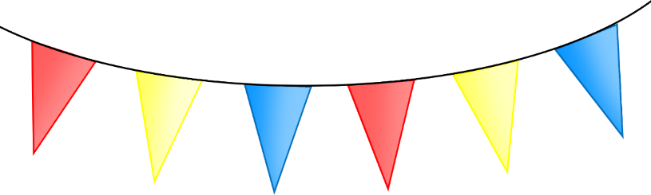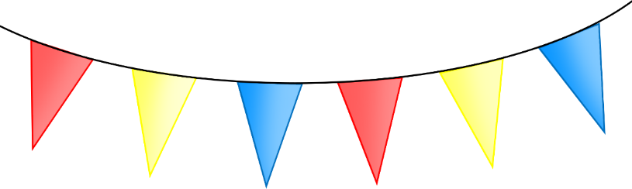

|  |  |  |
| --- | --- | --- |
| Stall/Event | Helper 1 | Helper 2 |
|  |  |  |
|  |  |  |
|  |  |  |
|  |  |  |
|  |  |  |
|  |  |  |
|  |  |  |
|  |  |  |
|  |  |  |
|  |  |  |
|  |  |  |
|  |  |  |
|  |  |  |
|  |  |  |
|  |  |  |
|  |  |  |
|  |  |  |
|  |  |  |
|  |  |  |
|  |  |  |

© 2023 Little Owls Resources