© 2023 Little Owls Resources

Date:

Where:

Events:

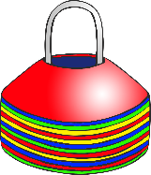

**Sports Day!**



**Don’t forget!**



© 2023 Little Owls Resources

Date:

Where:

Events:



**Sports Day!**



**Don’t forget!**



Don’t forget:

© 2023 Little Owls Resources

Date:

Where:

Events:



**Sports Day!**



© 2023 Little Owls Resources

Date:

Where:

Events:



**Sports Day!**



Don’t forget: