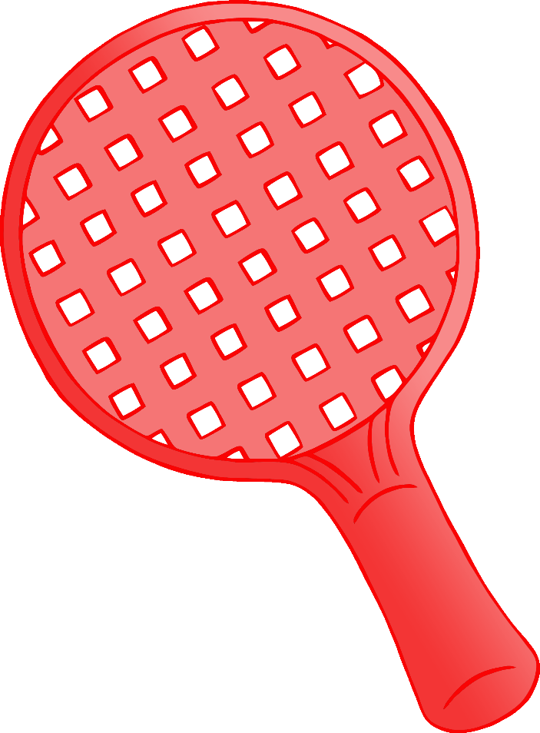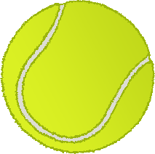

**After playing sport…**

**Wash your hands!**