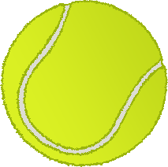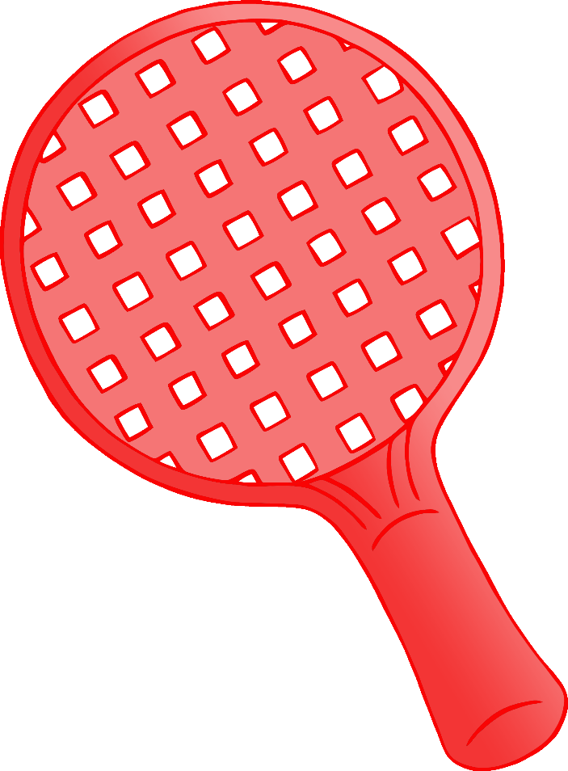

© 2020 Little Owls Resources

**After playing sport…**

**Wash your hands!**