Sport Skills - A5 Cards

© 2021 Little Owls Resources

N.B. Fold along the line and laminate before use.

Sport Skills

Kick ball

Kick

© 2021 Little Owls Resources

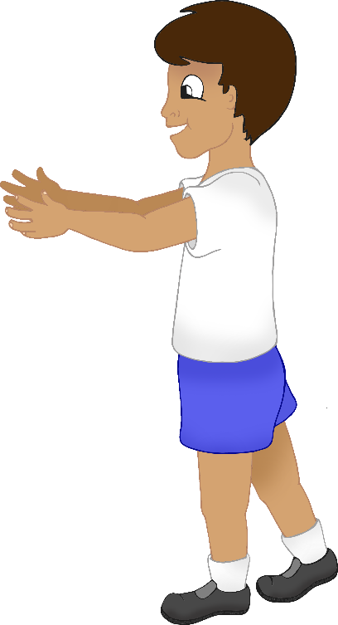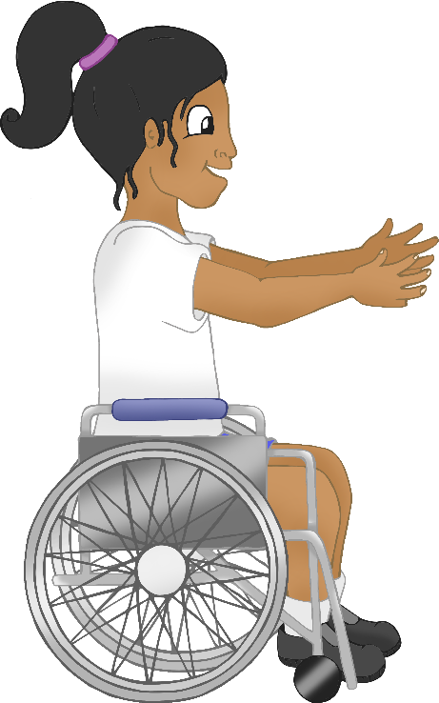

© 2021 Little Owls Resources

Throw

Catch

Sport Skills

Throw and catch - Ball

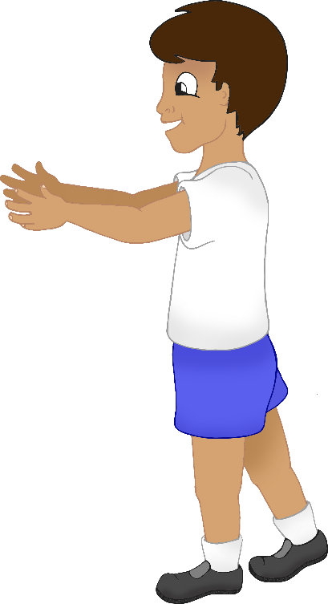

© 2021 Little Owls Resources

Catch

Throw

Sport Skills

Throw and catch - Beanbag

© 2021 Little Owls Resources

Roll

Gather

Sport Skills

Roll and gather

© 2021 Little Owls Resources

Sport Skills

Throw beanbag to target

Throw

© 2021 Little Owls Resources

Catch

Bounce

Sport Skills

Bounce ball and catch