Throw and catch - Ball

Sport Skills

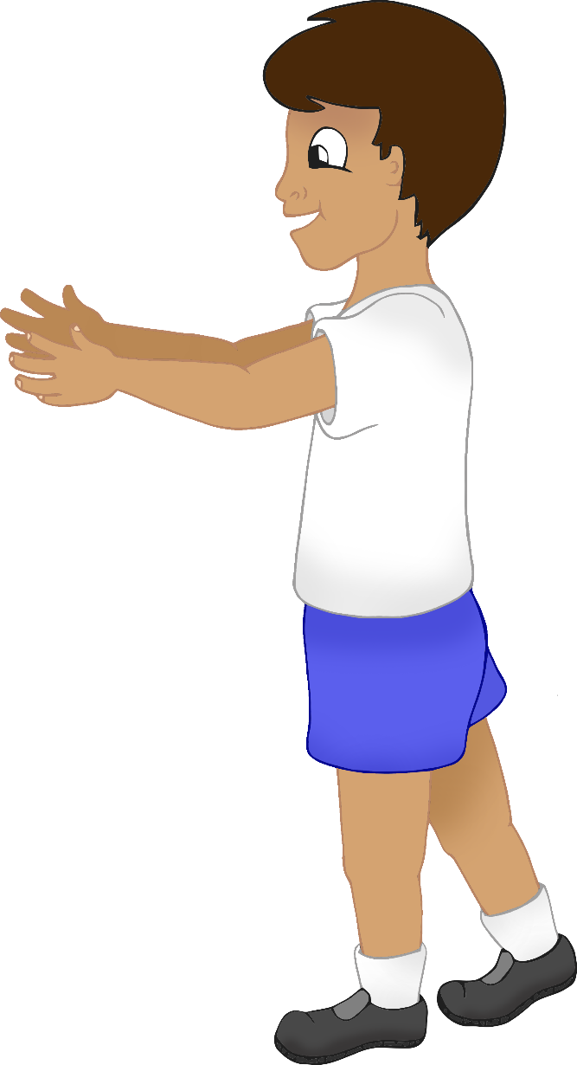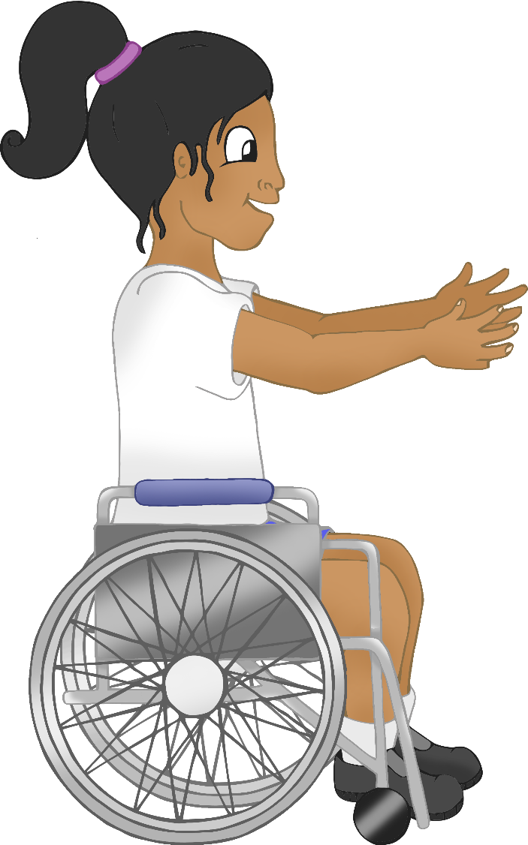

© 2021 Little Owls Resources

Throw and catch - Beanbag

Sport Skills

© 2021 Little Owls Resources

Roll and gather

Sport Skills

© 2021 Little Owls Resources

Throw beanbag to target

Sport Skills

© 2021 Little Owls Resources

Kick ball

Sport Skills

© 2021 Little Owls Resources

© 2021 Little Owls Resources

Bounce ball and catch

Sport Skills