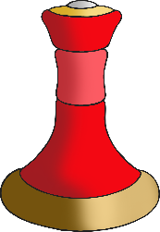

**Draw a special gift that you have received.**

© 2020 Little Owls Resources