© 2021 Little Owls Resources

**Help the sparrow get to the birdfeeder!**

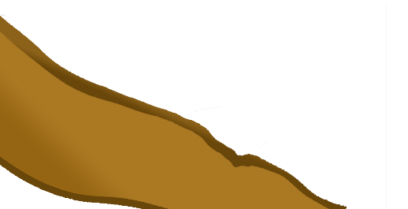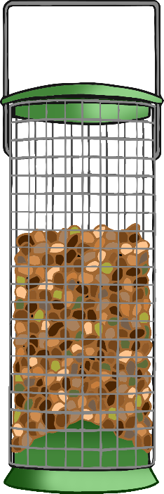

© 2021 Little Owls Resources

**Help the sparrow get to the birdfeeder!**



© 2021 Little Owls Resources

**Help the sparrow get to the birdfeeder!**



© 2021 Little Owls Resources

**Help the sparrow get to the birdfeeder!**

