**Help the sparrows get to the birdfeeders!** (1)

© 2021 Little Owls Resources

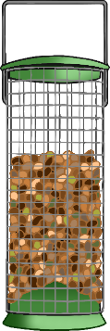

**Help the sparrows get to the birdfeeders!** (2)

© 2021 Little Owls Resources

