**Sparrow body parts**

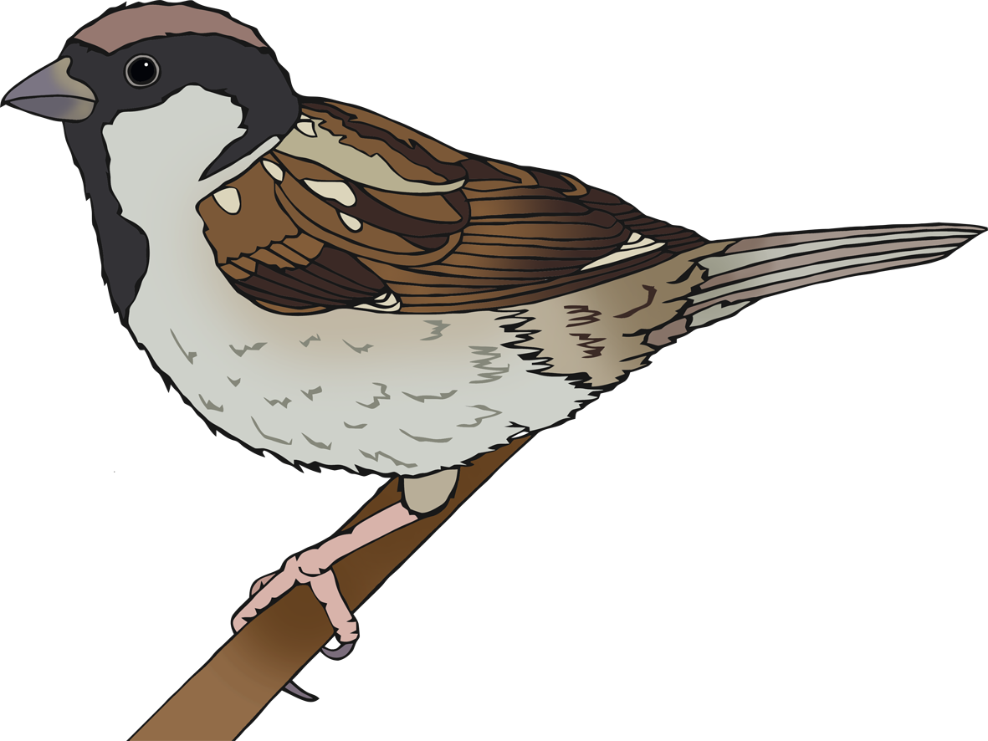

© 2021 Little Owls Resources

e

**w**

t

b

l



**Sparrow body parts**

© 2021 Little Owls Resources

leg

beak

**w**ing



eye

tail

**Sparrow body parts**

© 2021 Little Owls Resources