Sound Walk

Stop… Listen… What can you hear?

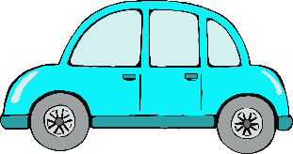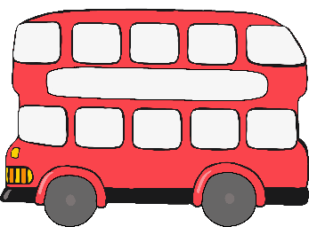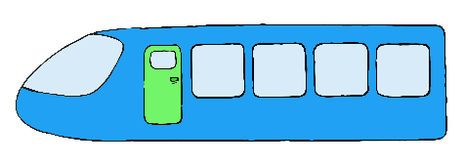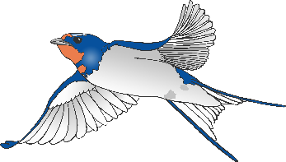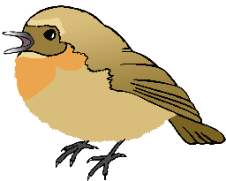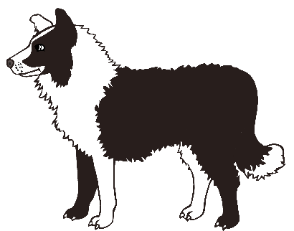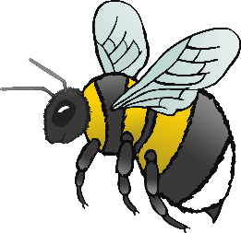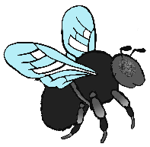

Other…

Aeroplane

Birds

Car

Bees / Flies

Bus

Wind blowing

trees

Dog

Traffic crossing

beeps

Train

|  |  |
| --- | --- |
| Sound | Tally |
|  |  |
|  |  |
|  |  |
|  |  |
|  |  |
|  |  |
|  |  |
|  |  |
|  |  |
|  |  |

Sound Walk Tally