Sort Recycling Cards

Fold along line and then laminate.

Idea:

When the cards are prepared, lay them out either picture side up or down. Child(ren) to choose a card and then decide, with discussion if necessary, where the card belongs.

Follow-up:

Find real-life items to add to the game. Which group do they belong to?

© 2021 Little Owls Resources

© 2021 Little Owls Resources

© 2021 Little Owls Resources

© 2021 Little Owls Resources

© 2021 Little Owls Resources

© 2021 Little Owls Resources

© 2021 Little Owls Resources

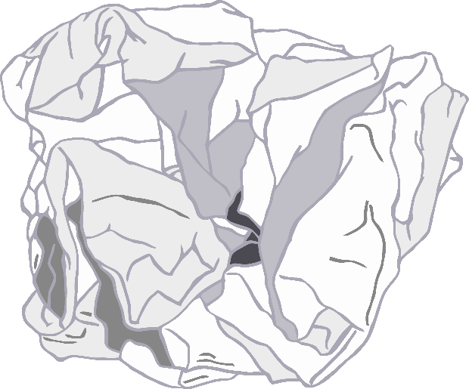

© 2021 Little Owls Resources

© 2021 Little Owls Resources

© 2021 Little Owls Resources

© 2021 Little Owls Resources

© 2021 Little Owls Resources

© 2021 Little Owls Resources

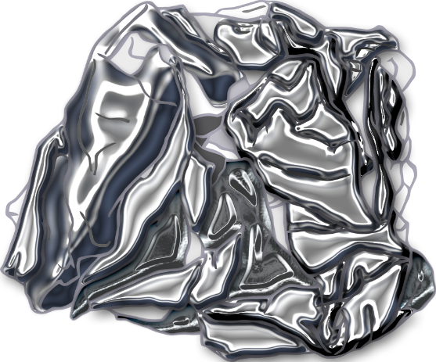

© 2021 Little Owls Resources

© 2021 Little Owls Resources

© 2021 Little Owls Resources

© 2021 Little Owls Resources

© 2021 Little Owls Resources

© 2021 Little Owls Resources

© 2021 Little Owls Resources

© 2021 Little Owls Resources

© 2021 Little Owls Resources

© 2021 Little Owls Resources

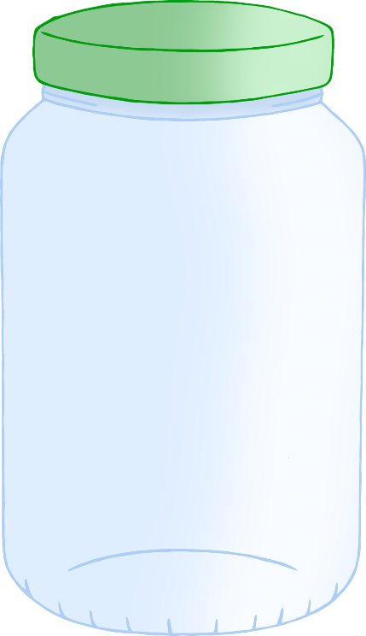

© 2021 Little Owls Resources

© 2021 Little Owls Resources

© 2021 Little Owls Resources

**Plastic**

© 2021 Little Owls Resources

**Paper**

Or

**Card**

© 2021 Little Owls Resources

**Metal**

© 2021 Little Owls Resources

**Food Waste**

© 2021 Little Owls Resources

**Garden Waste**

© 2021 Little Owls Resources

**Glass**