**Earth**

© 2021 Little Owls Resources

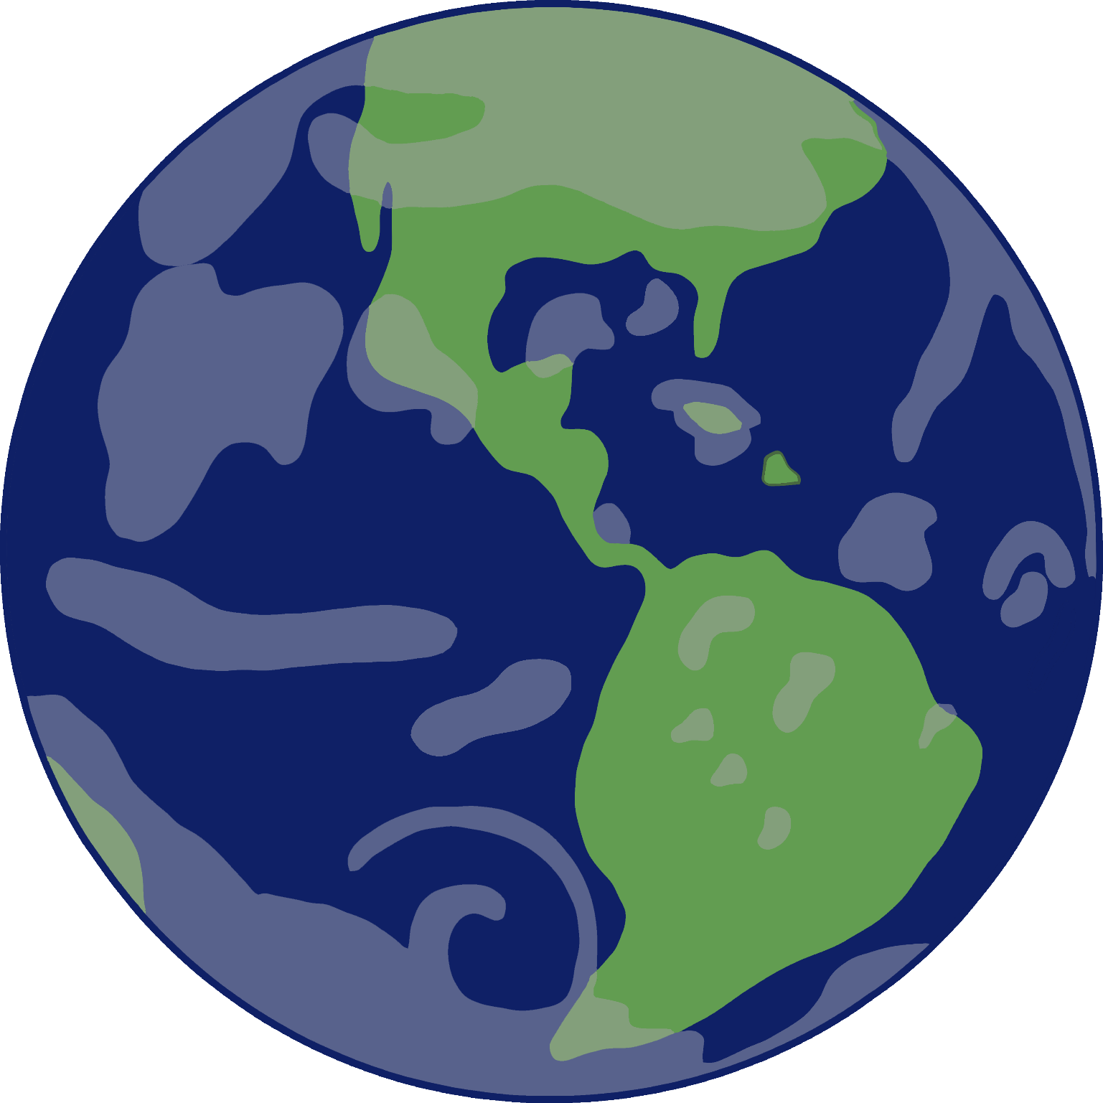

**Venus**

© 2021 Little Owls Resources

**Uranus**

© 2021 Little Owls Resources

**The Moon**

© 2021 Little Owls Resources

**Sun**

© 2021 Little Owls Resources

**Saturn**

© 2021 Little Owls Resources

**Pluto**

© 2021 Little Owls Resources

**Neptune**

© 2021 Little Owls Resources

**Mercury**

© 2021 Little Owls Resources

**Mars**

© 2021 Little Owls Resources

**Jupiter**

© 2021 Little Owls Resources

**Ceres**

© 2021 Little Owls Resources