**Wash your hands!**

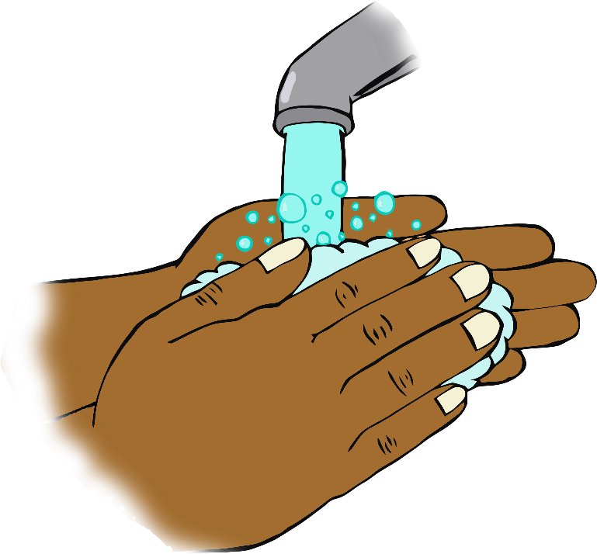

**Wash your hands!**