**Sleeping Bunnies**

© 2020 Little Owls Resources

**See the little bunny rabbits sleeping till its noonShall we go and wake them with a merry tune?They're so still, are they ill?WAKE UP LITTLE BUNNIES!**

**Hop little bunnies, hop, hop, hopHop little bunnies, hop, hop, hopHop little bunnies, hop, hop, hopHop, hop, hop.**

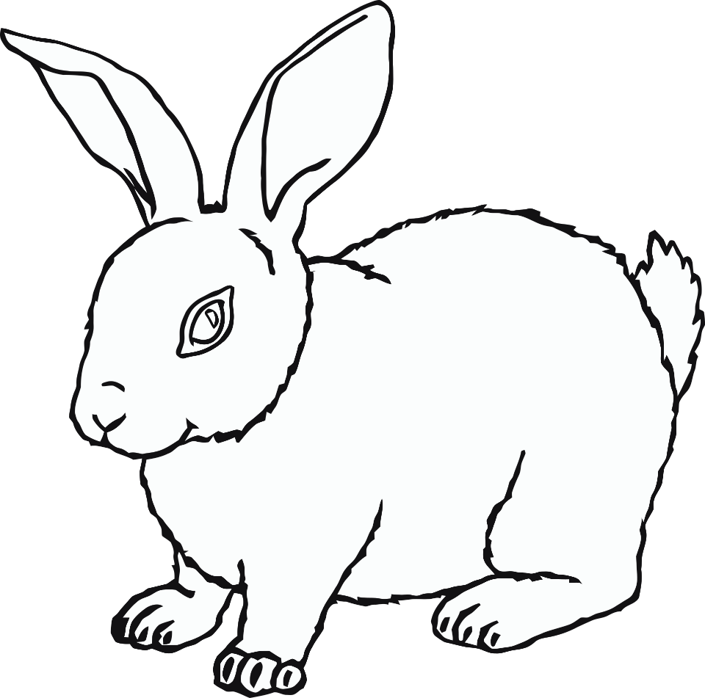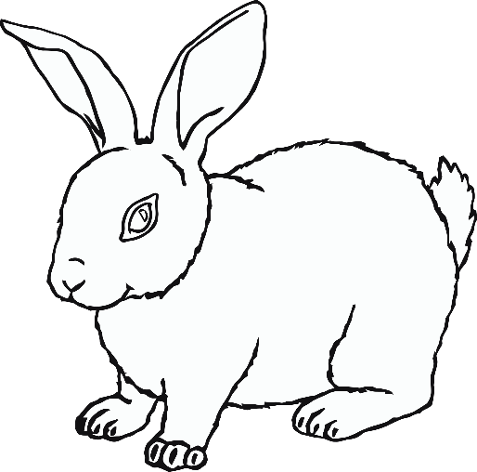

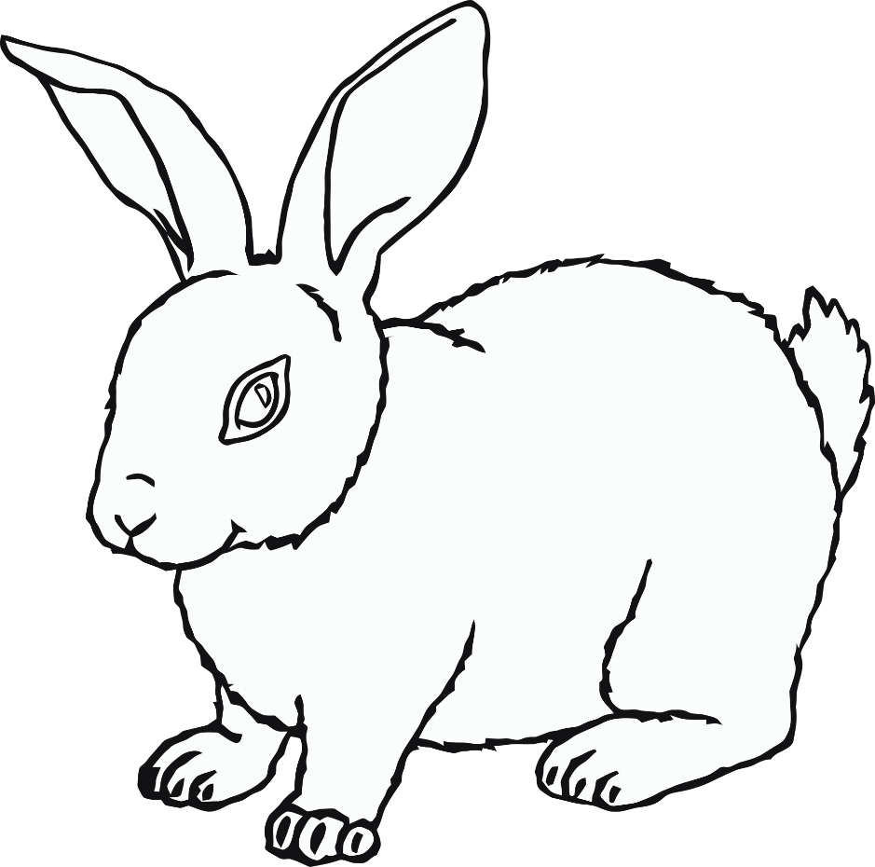

(Children lie down on the floor)

See the little bunny rabbits sleeping till its noonShall we go and wake them with a merry tune?They're so still, are they ill?WAKE UP LITTLE BUNNIES!

(Children jump up and start jumping/hopping)

Hop little bunnies, hop, hop, hopHop little bunnies, hop, hop, hopHop little bunnies, hop, hop, hopHop, hop, hop.

**Sleeping Bunnies**

© 2021 Little Owls Resources