Sleeping Bunnies

© 2021 Little Owls Resources

See the little bunny rabbits sleeping till its noonShall we go and wake them with a merry tune?They're so still, are they ill?WAKE UP LITTLE BUNNIES!

Hop little bunnies, hop, hop, hopHop little bunnies, hop, hop, hopHop little bunnies, hop, hop, hopHop, hop, hop.

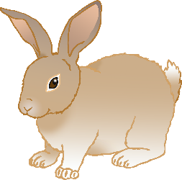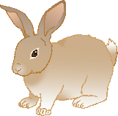

Sleeping Bunnies

See the little bunny rabbits sleeping till its noonShall we go and wake them with a merry tune?They're so still, are they ill?WAKE UP LITTLE BUNNIES!

Hop little bunnies, hop, hop, hopHop little bunnies, hop, hop, hopHop little bunnies, hop, hop, hopHop, hop, hop.



Sleeping Bunnies

See the little bunny rabbits sleeping till its noonShall we go and wake them with a merry tune?They're so still, are they ill?WAKE UP LITTLE BUNNIES!

Hop little bunnies, hop, hop, hopHop little bunnies, hop, hop, hopHop little bunnies, hop, hop, hopHop, hop, hop.



Sleeping Bunnies

See the little bunny rabbits sleeping till its noonShall we go and wake them with a merry tune?They're so still, are they ill?WAKE UP LITTLE BUNNIES!

Hop little bunnies, hop, hop, hopHop little bunnies, hop, hop, hopHop little bunnies, hop, hop, hopHop, hop, hop.



© 2021 Little Owls Resources

© 2021 Little Owls Resources

© 2021 Little Owls Resources