© 2021 Little Owls Resources

See the little bunny rabbits sleeping till its noon.

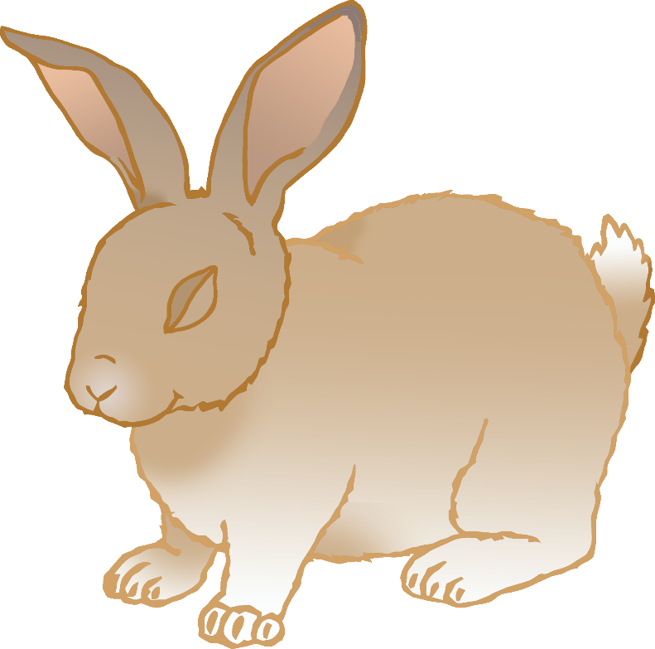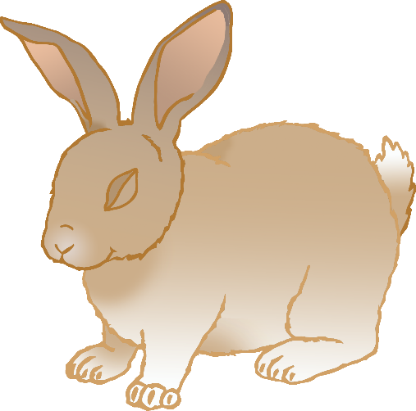

Z

Z

Z

Z

Z

Z

Z

Z

Shall we go and wake them with a merry tune?

© 2021 Little Owls Resources

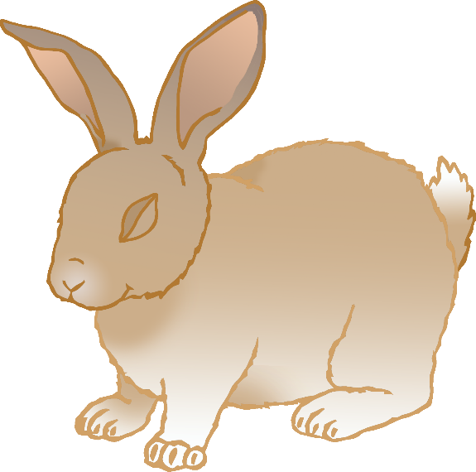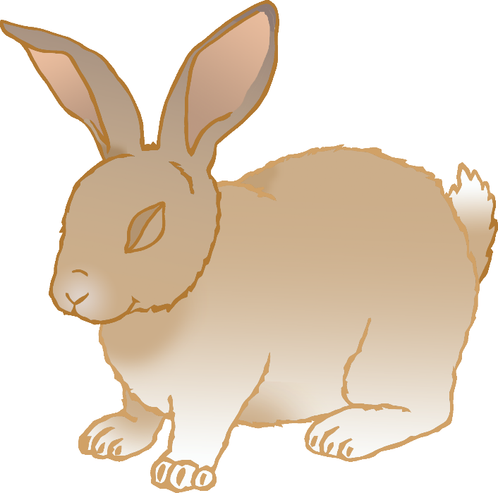

?

?

They're so still, are they ill?

© 2021 Little Owls Resources

© 2021 Little Owls Resources

WAKE UP!

WAKE UP LITTLE BUNNIES!

Hop little bunnies, hop, hop, hopHop little bunnies, hop, hop, hopHop little bunnies, hop, hop, hopHop, hop, hop.

© 2021 Little Owls Resources