Sleep

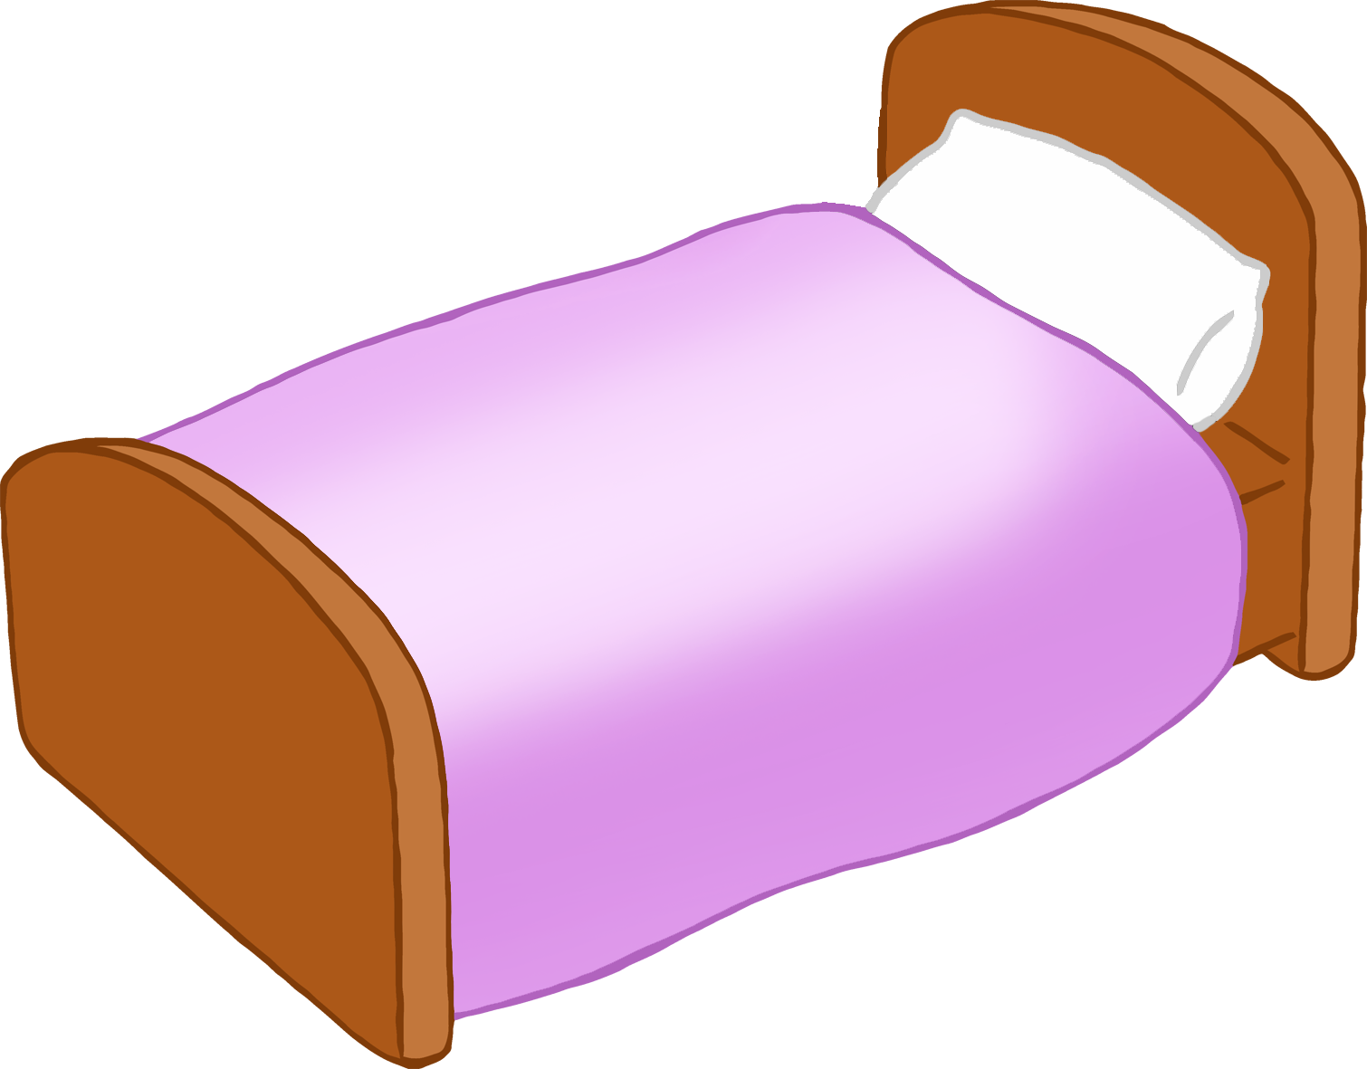

© 2023 Little Owls Resources