Signs of Winter

Lots of trees without leaves.

Signs of Winter

We wear our winter clothes.

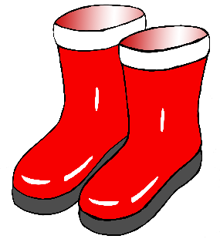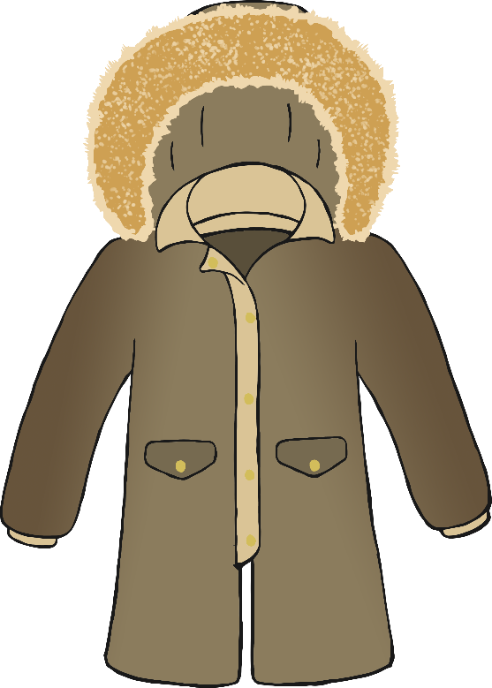

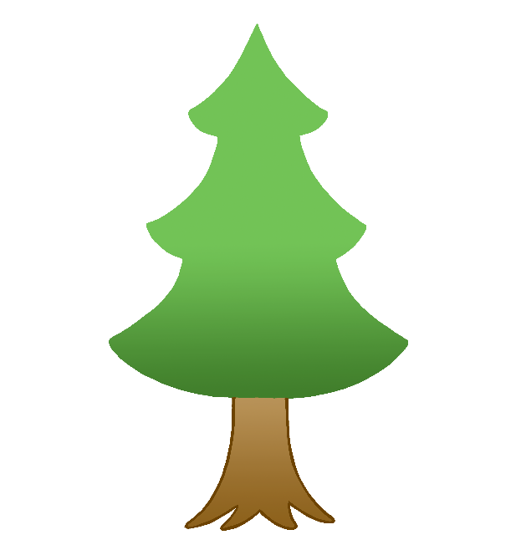

Signs of Winter

Robins in the garden.

Signs of Winter

Frost.

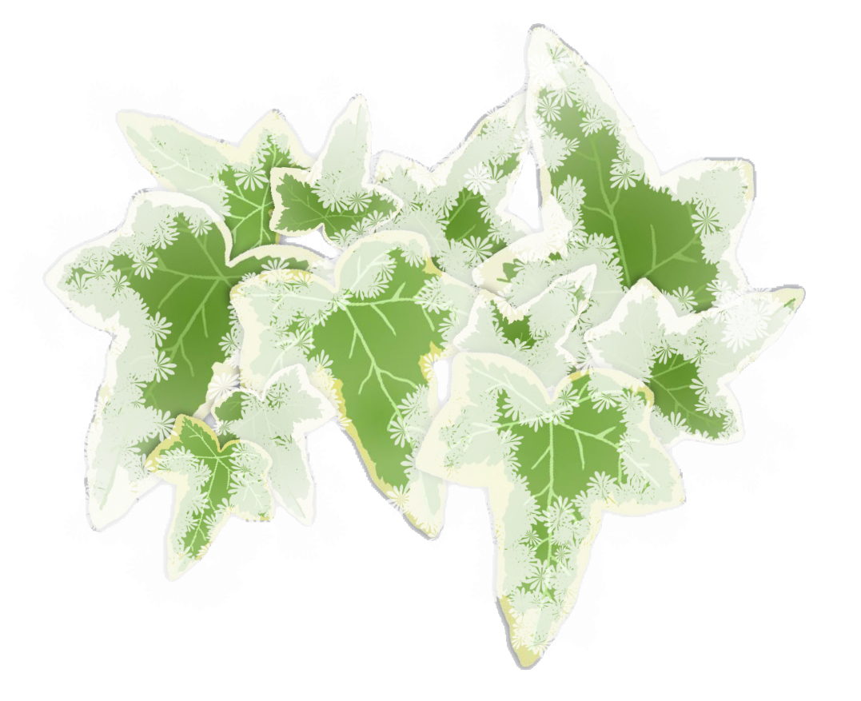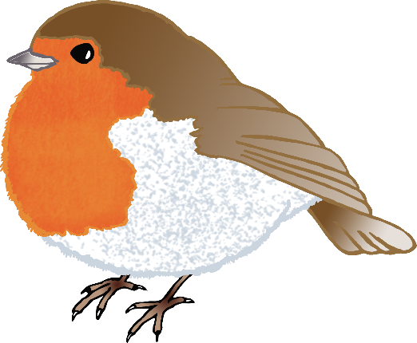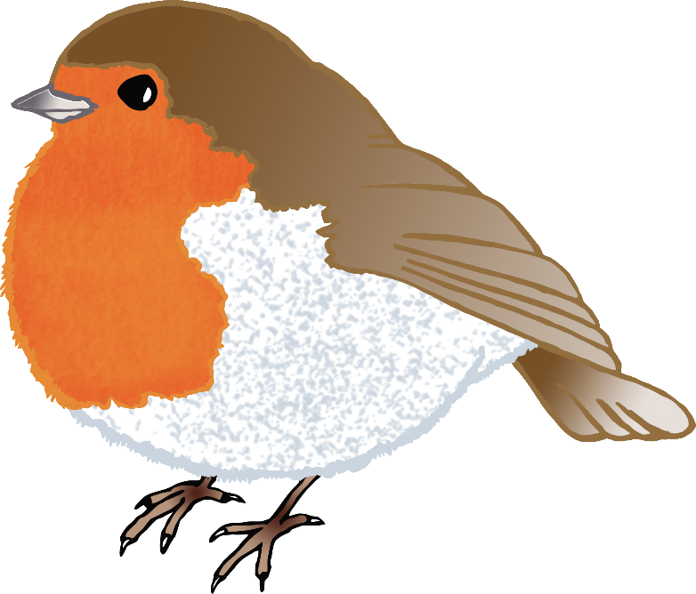

Signs of Winter

Making snowballs and snowmen.

Signs of Winter

You can see your breath in the air!

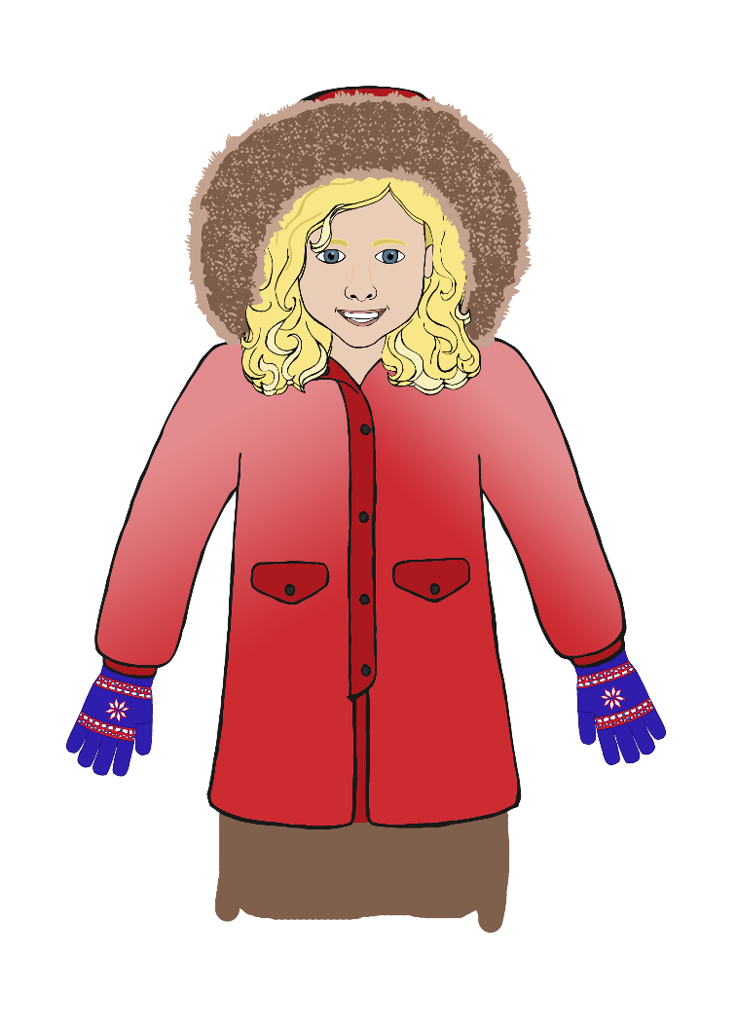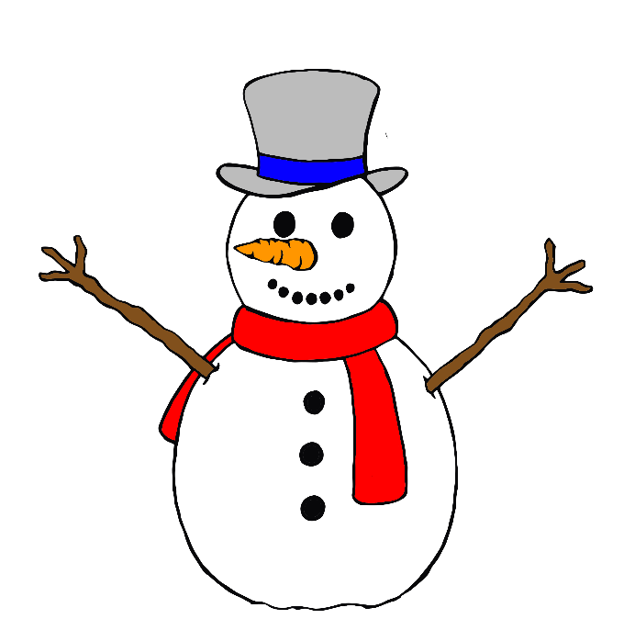

Signs of Winter

Snowdrops growing in the cold.

Signs of Winter

Berries on holly.

Signs of Winter

Water freezes into ice.

Signs of Winter

Winter animals that are not hibernating.

