Signs of Winter

We wear our winter clothes.

© 2019 Little Owls Resources

www.littleowlsresources.com

Signs of Winter

Lots of trees without leaves.

© 2019 Little Owls Resources

www.littleowlsresources.com

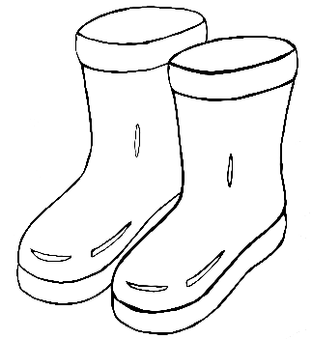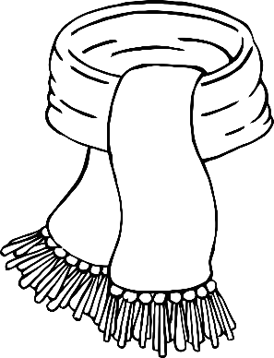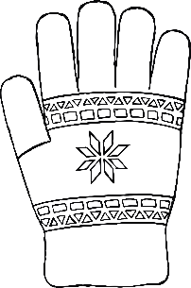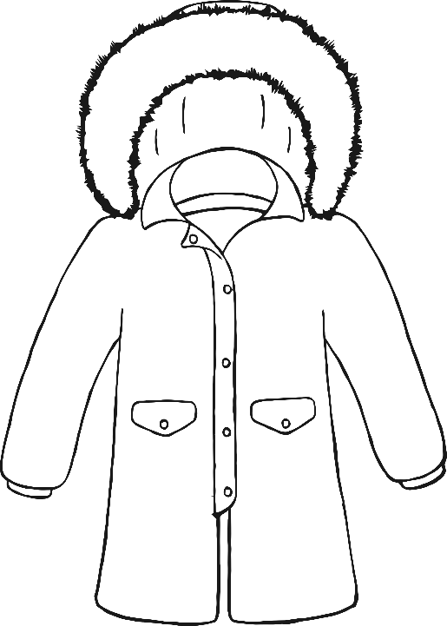

Signs of Winter

Frost.

© 2019 Little Owls Resources

www.littleowlsresources.com

Signs of Winter

Robins in the garden.

© 2019 Little Owls Resources

www.littleowlsresources.com

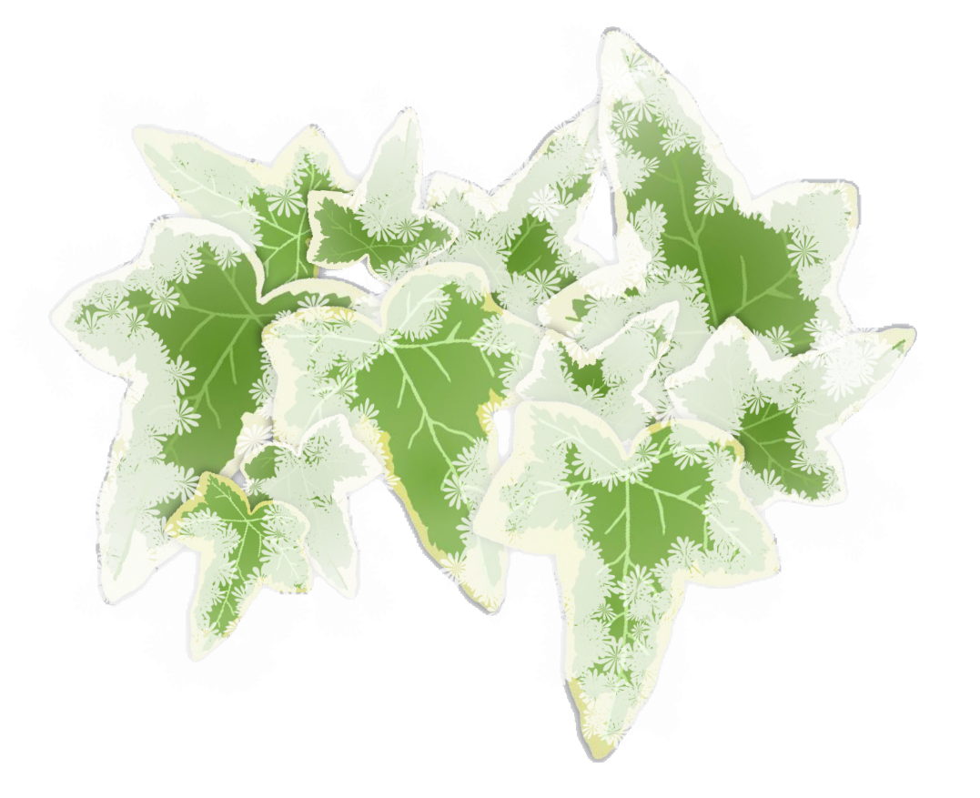

Signs of Winter

Making snowballs and snowmen.

© 2019 Little Owls Resources

www.littleowlsresources.com

Signs of Winter

You can see your breath in the air!

© 2019 Little Owls Resources

www.littleowlsresources.com

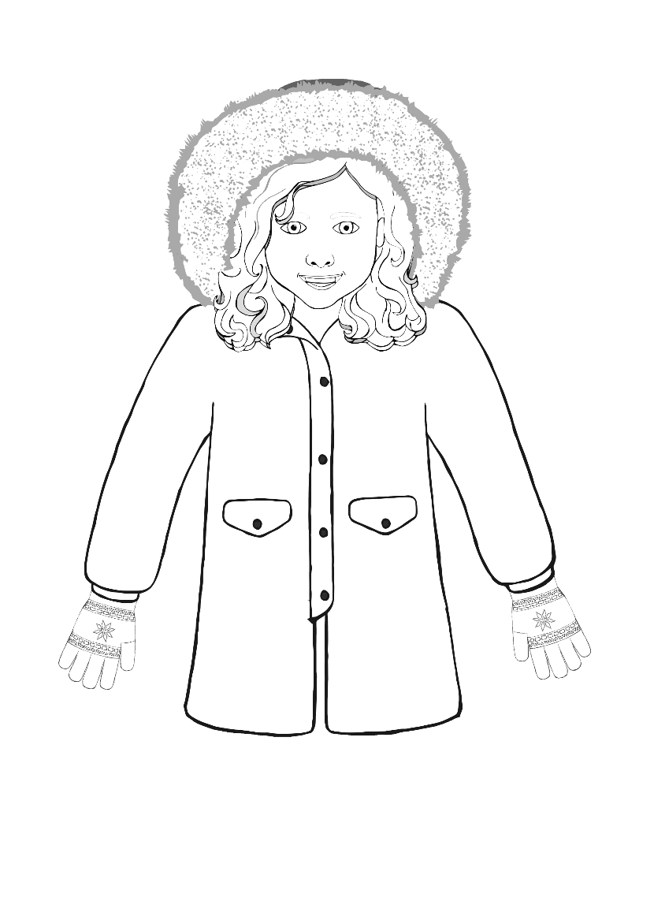

Signs of Winter

Berries on holly.

© 2019 Little Owls Resources

www.littleowlsresources.com

Signs of Winter

Snowdrops growing in the cold.

© 2019 Little Owls Resources

www.littleowlsresources.com

Signs of Winter

Winter animals that are not hibernating.

© 2019 Little Owls Resources

www.littleowlsresources.com

Signs of Winter

Water freezes into ice.

© 2019 Little Owls Resources

www.littleowlsresources.com

