**Signs of Summer**

**Signs of Summer**

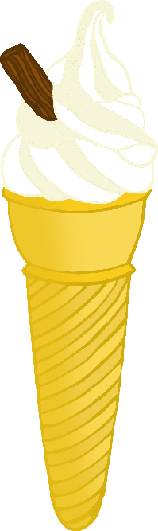

© 2021 Little Owls Resources

© 2021 Little Owls Resources

People are enjoying ice-creams and lollies!

Trees are FULL of leaves!

**Signs of Summer**

**Signs of Summer**

Thunderstorms!

Wearing sun cream.

© 2021 Little Owls Resources

© 2021 Little Owls Resources

© 2021 Little Owls Resources

© 2021 Little Owls Resources

Sunflowers stretching tall!

Sandcastles at the beach.

**Signs of Summer**

**Signs of Summer**

**Signs of Summer**

**Signs of Summer**

Wearing sunhats!

Lots of daisies!

© 2021 Little Owls Resources

© 2021 Little Owls Resources

Sunshine and blue skies!

Buckets and spades at the seaside!

© 2021 Little Owls Resources

© 2021 Little Owls Resources

**Signs of Summer**

**Signs of Summer**