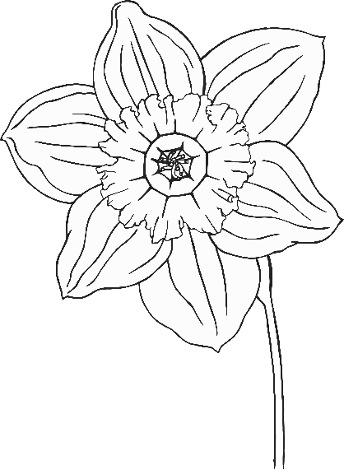

Signs of Spring

Signs of Spring

Lots of daffodils!

Bluebells in

the woods.

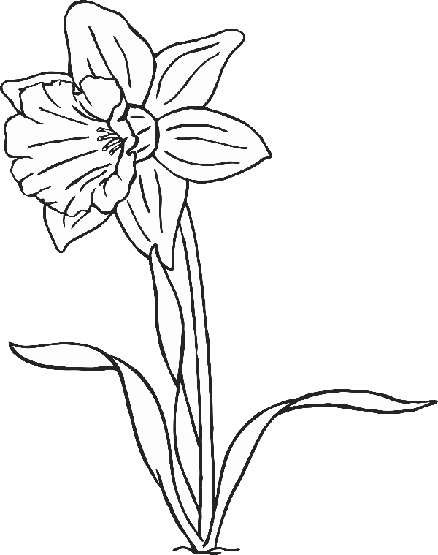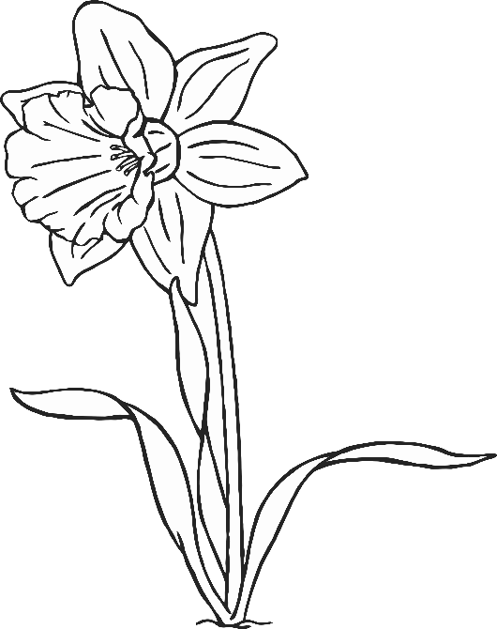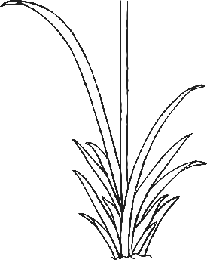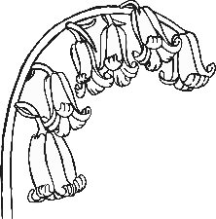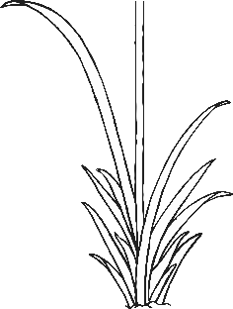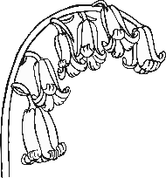

© 2019 Little Owls Resources

© 2019 Little Owls Resources

Signs of Spring

Signs of Spring

Buzzing Bees.

Blossom on the trees.

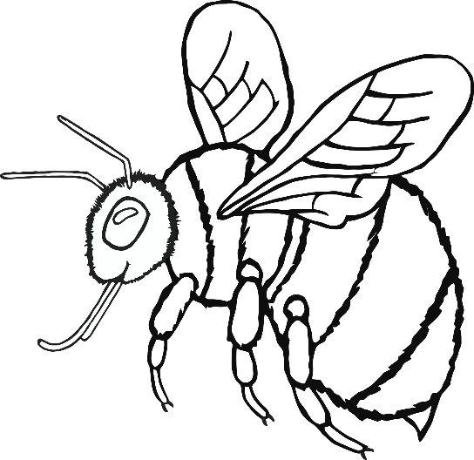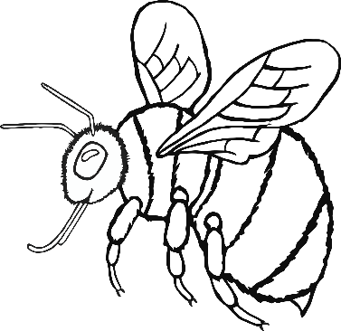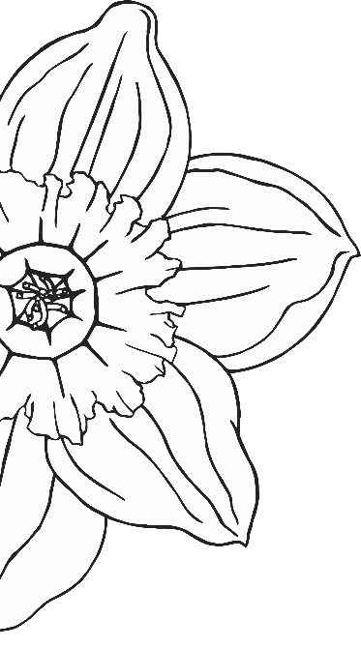

© 2019 Little Owls Resources

© 2019 Little Owls Resources

Signs of Spring

Signs of Spring

Frogs, tadpoles and frogspawn in ponds.

Butterflies!

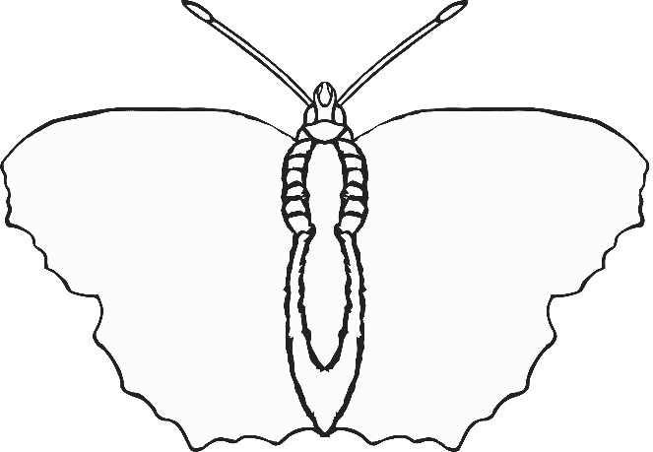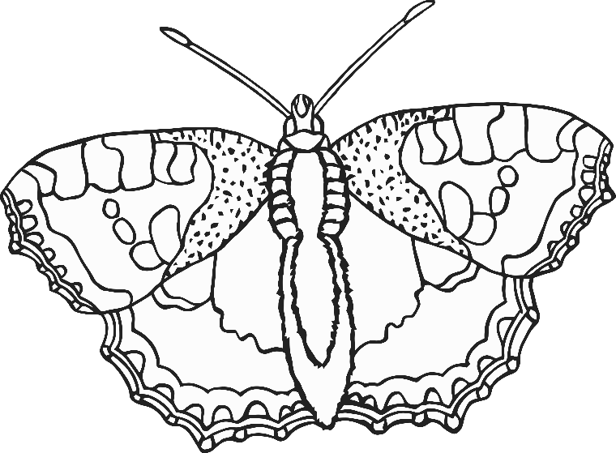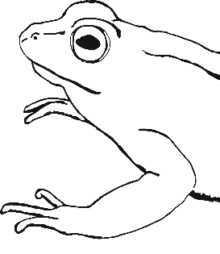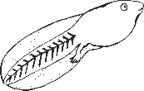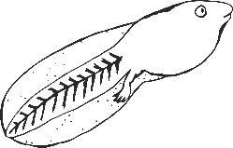

© 2019 Little Owls Resources

© 2019 Little Owls Resources

Signs of Spring

Signs of Spring

Ducklings on

the pond.

Chicks!

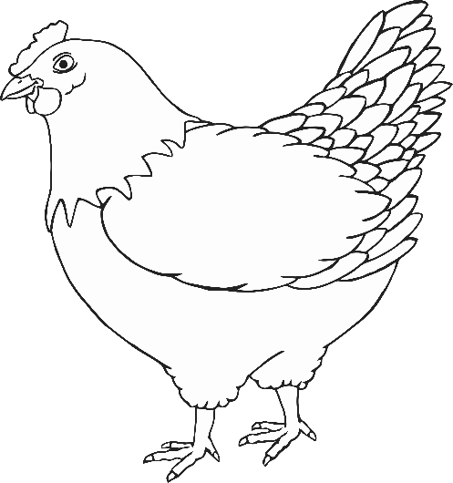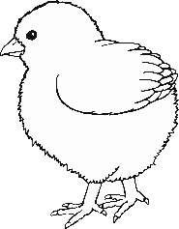

© 2019 Little Owls Resources

© 2019 Little Owls Resources

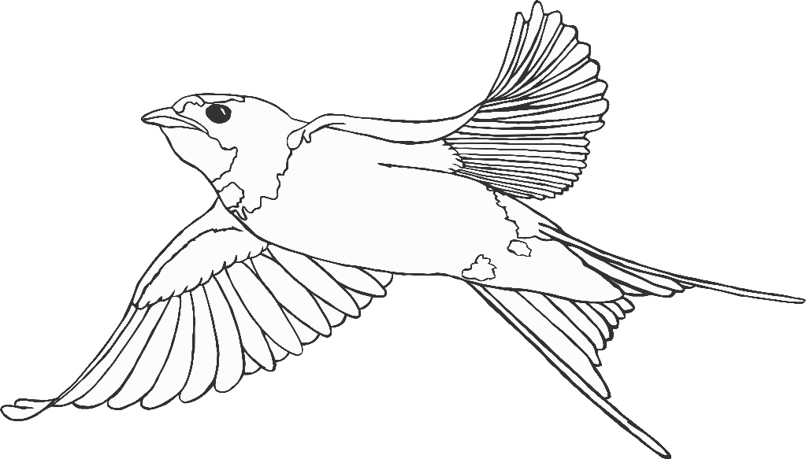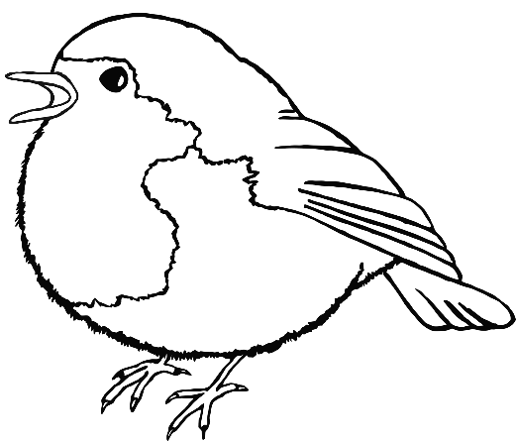

Signs of Spring

Signs of Spring

More birdsong in

the morning.

Swallows return

from the south.

© 2019 Little Owls Resources

© 2019 Little Owls Resources

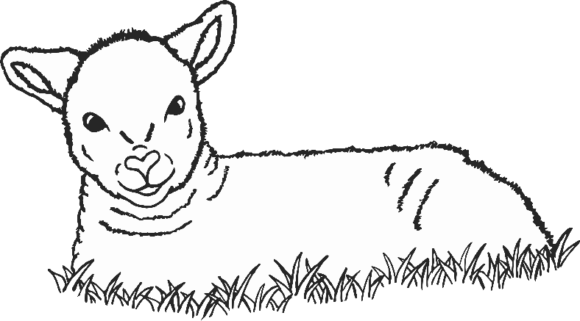

© 2019 Little Owls Resources

© 2019 Little Owls Resources

Signs of Spring

Signs of Spring

Lambs in the fields.