**Signs of Autumn**

**Signs of Autumn**

Falling leaves

Spinning sycamore seeds.

© 2022 Little Owls Resources

© 2022 Little Owls Resources

Signs of Autumn

Signs of Autumn

© 2022 Little Owls Resources

© 2022 Little Owls Resources

Birds flying south

for the winter.

Acorns!

Conkers!

Signs of Autumn

Signs of Autumn

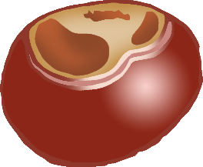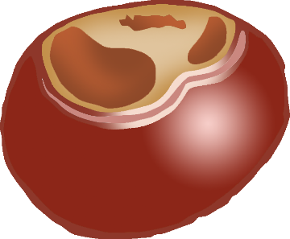

© 2022 Little Owls Resources

© 2022 Little Owls Resources

Hedgehogs feeding up for the winter.

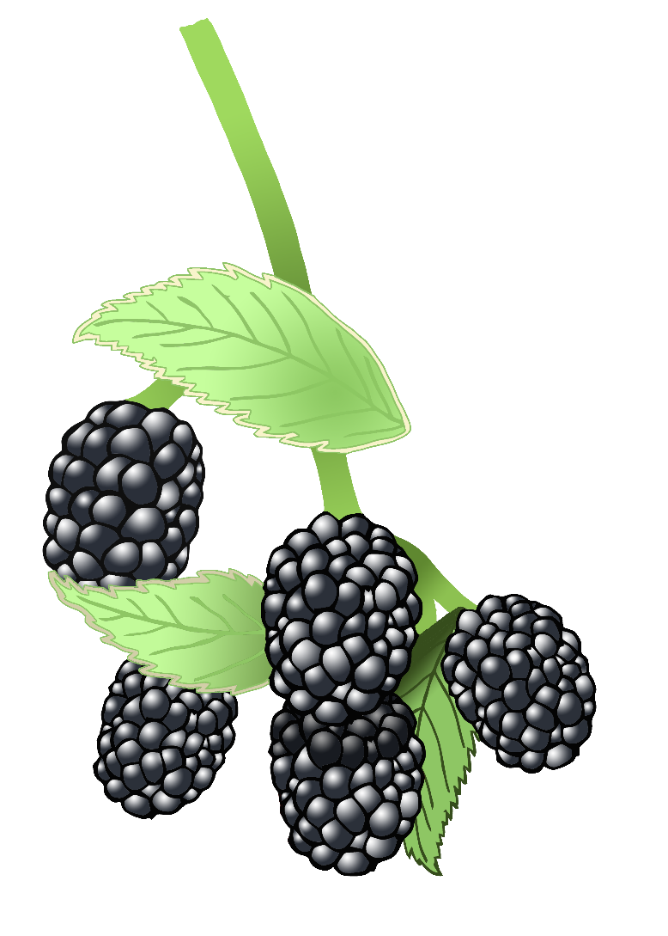

© 2022 Little Owls Resources

© 2022 Little Owls Resources

Blackberries on the bushes.

Signs of Autumn

Signs of Autumn

Squirrels gathering nuts and berries.

© 2022 Little Owls Resources

© 2022 Little Owls Resources

Signs of Autumn

Signs of Autumn

Morning dew on the grass.

Fungus growing.

(Look but don’t touch!)