Signs of Autumn

Signs of Autumn

Falling leaves

Spinning sycamore seeds.

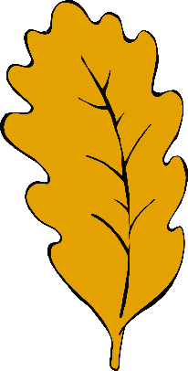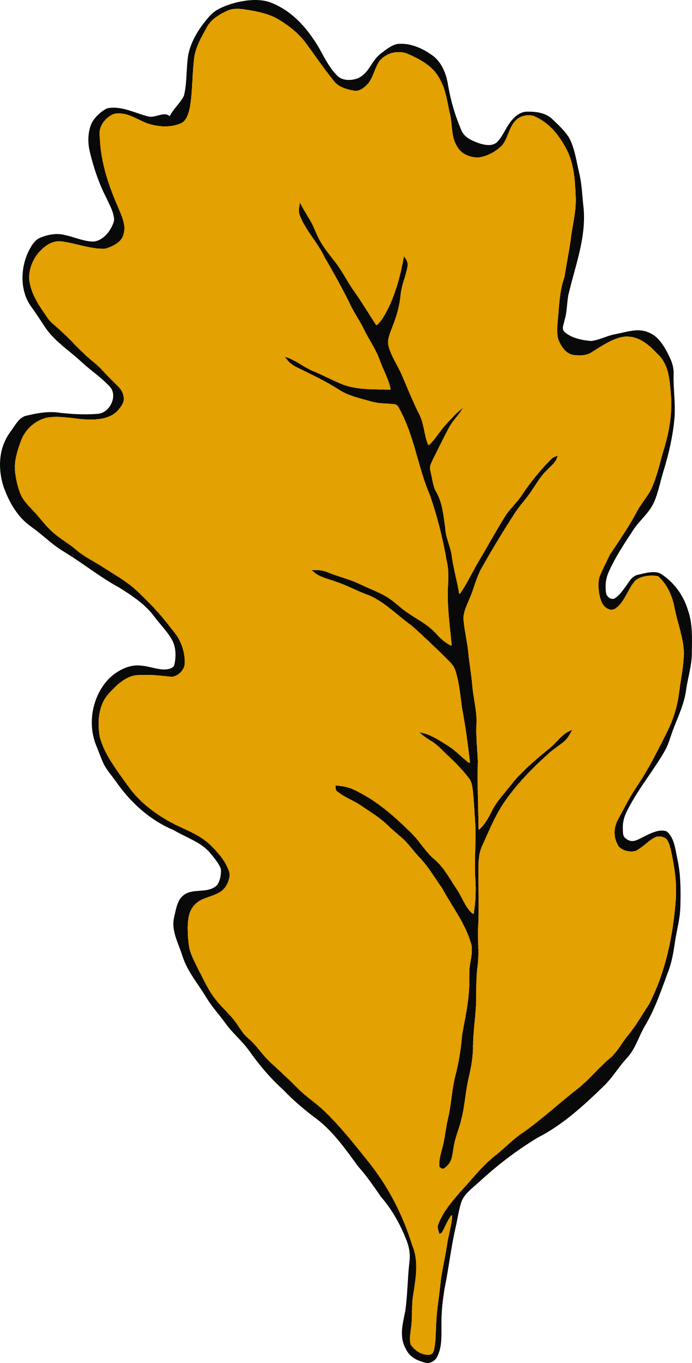

www.littleowls-premium.com © 2019 Little Owls Resources

www.littleowls-premium.com © 2019 Little Owls Resources

Signs of Autumn

Signs of Autumn

Birds flying south

for the winter.

Acorns!

www.littleowls-premium.com © 2019 Little Owls Resources

www.littleowls-premium.com © 2019 Little Owls Resources

Signs of Autumn

Signs of Autumn

Hedgehogs feeding up for the winter.

Conkers!

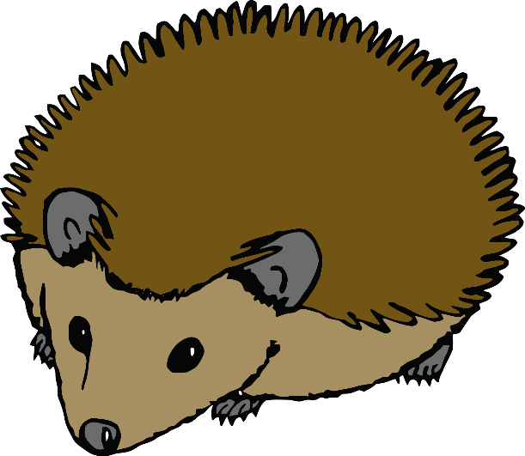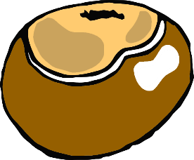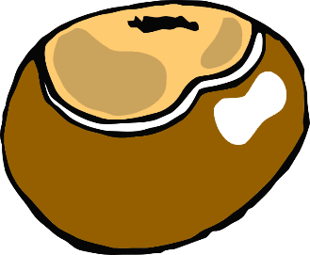

www.littleowls-premium.com © 2019 Little Owls Resources

www.littleowls-premium.com © 2019 Little Owls Resources

Signs of Autumn

Signs of Autumn

Squirrels gathering nuts and berries.

Blackberries on the bushes.

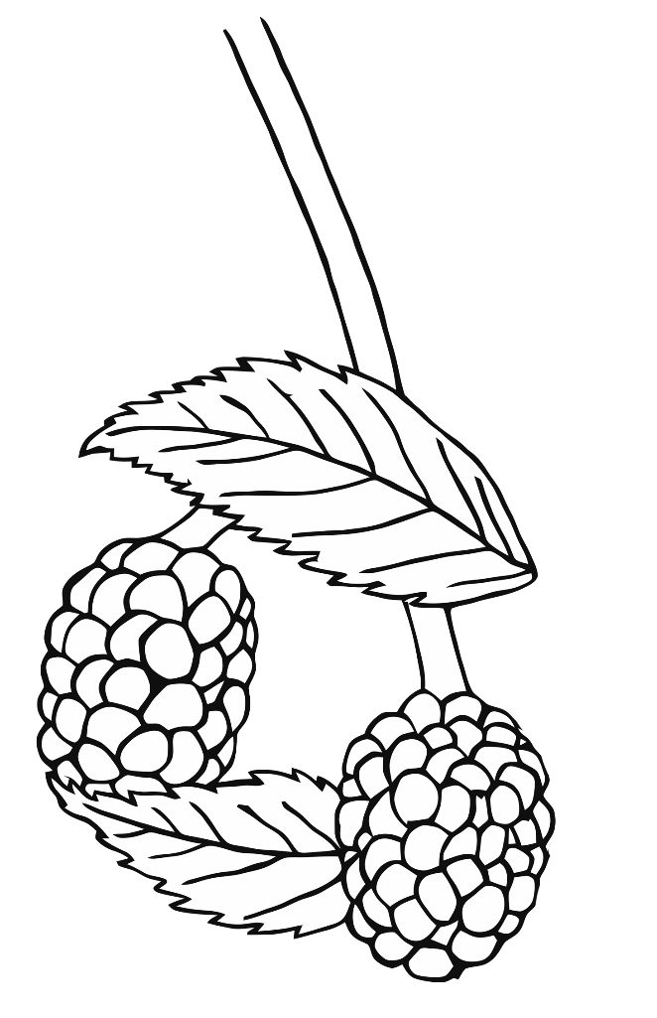

www.littleowls-premium.com © 2019 Little Owls Resources

www.littleowls-premium.com © 2019 Little Owls Resources

Signs of Autumn

Signs of Autumn

Morning dew on the grass.

Fungus growing.

(Look but don’t touch!)

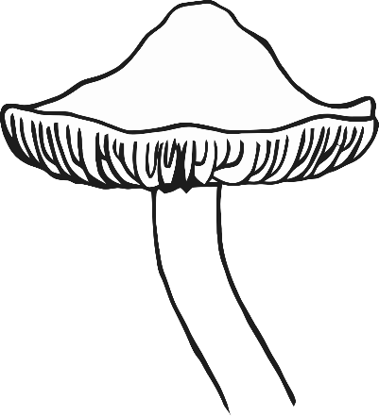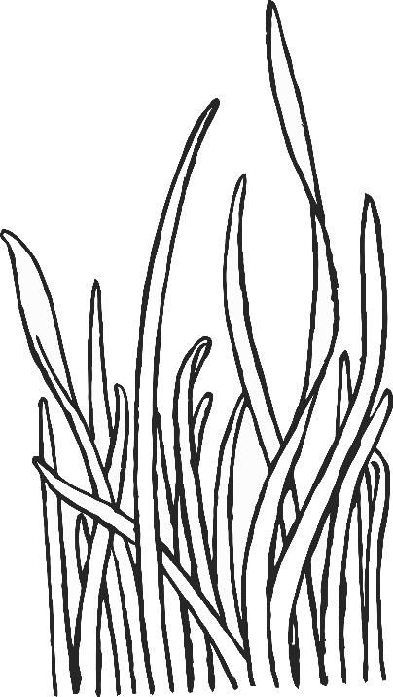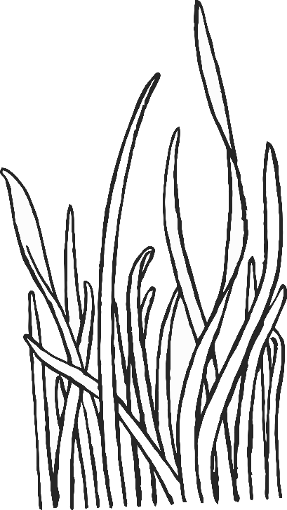

www.littleowls-premium.com © 2019 Little Owls Resources

www.littleowls-premium.com © 2019 Little Owls Resources