Vestibular

(inner ear controls how we respond to movement and keeps us oriented when moving or stationary)

Sensory systems

Auditory

© 2023 Little Owls Resources

(recognition of sound)

Smell/Taste

Proprioception

(sensing where each part of our body is and how it is moving without needing to see it)

Interoception

Tactile

(response to light touch, pain and temperature through skin receptors)

(sensing internal signals from your body, e.g. a growling tummy indicating hunger, dry mouth for thirst, needing the toilet, feeling your heart race, physical sensations connected with emotions, etc.)

Vision

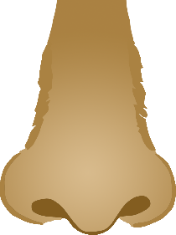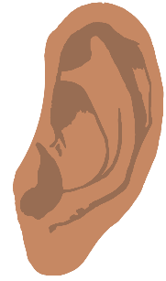

(sensing where each part of our body is and how it is moving without needing to see it)

Proprioception

Vision

Interoception

Auditory

(inner ear controls how we respond to movement and keeps us oriented when moving or stationary)

Vestibular

)

)

)

)

Smell/Taste

(recognition of sound)

(response to light touch, pain and temperature through skin receptors)

Tactile

(sensing internal signals from your body, e.g. a growling tummy indicating hunger, dry mouth for thirst, needing the toilet, feeling your heart race, physical sensations connected with emotions, etc.)

Sensory systems

© 2023 Little Owls Resources