Too dark

© 2023 Little Owls Resources

Too bright

© 2023 Little Owls Resources

Too hot

© 2023 Little Owls Resources

Too cold

© 2023 Little Owls Resources

Too **loud**

© 2023 Little Owls Resources

Too quiet

© 2023 Little Owls Resources

Too **loud**

© 2023 Little Owls Resources

Too quiet

© 2023 Little Owls Resources

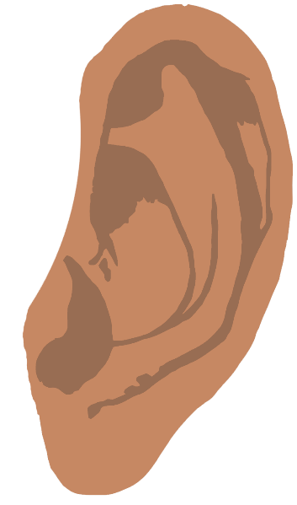

I like it

© 2023 Little Owls Resources

I don’t like it

© 2023 Little Owls Resources

**✓**



**X**

**X**

**✓**

**It feels** good

© 2023 Little Owls Resources

**It feels** bad

© 2023 Little Owls Resources



**X**

**✓**

© 2023 Little Owls Resources

© 2023 Little Owls Resources

It smells good

It smells bad

**It tastes** good

**X**

**✓**

© 2023 Little Owls Resources

© 2023 Little Owls Resources

**It tastes** bad

© 2023 Little Owls Resources

Just Right!