© 2024 Little Owls Resources

The Selkirk Grace

Some hae meat and canna eat.

And some wad eat that want it,

But we hae meat and we can eat,

Sae let the Lord be thankit!

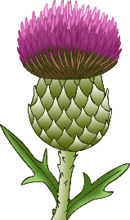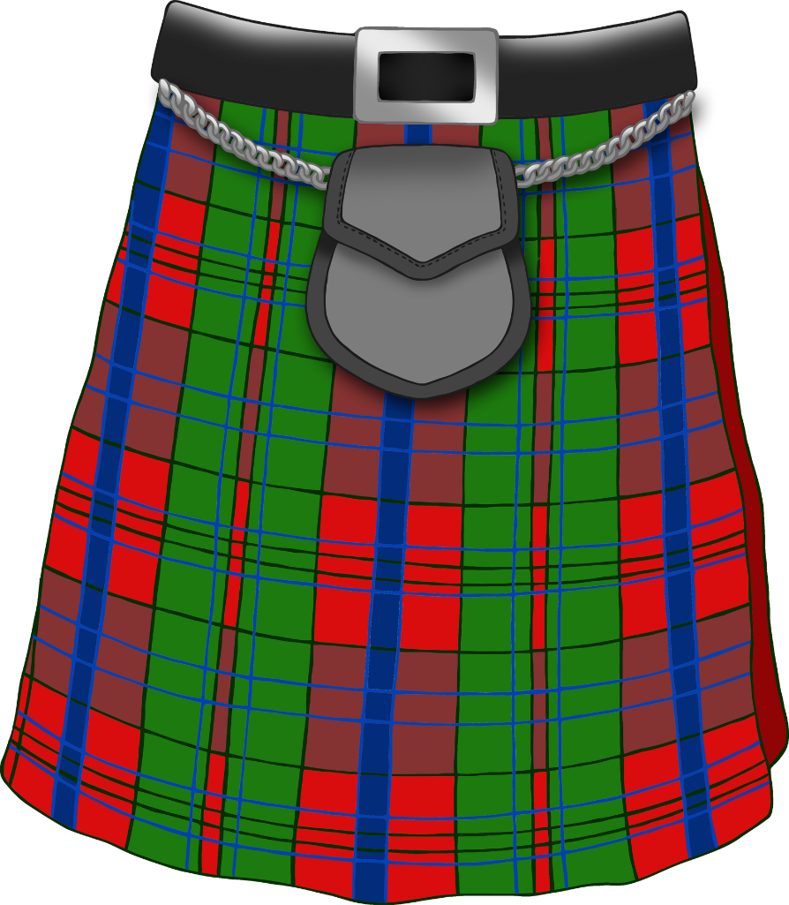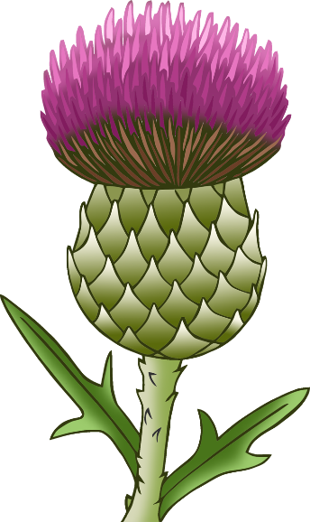

© 2024 Little Owls Resources

The Selkirk Grace

Some hae meat and canna eat.

And some wad eat that want it,

But we hae meat and we can eat,

Sae let the Lord be thankit!



© 2024 Little Owls Resources

The Selkirk Grace

Some hae meat and canna eat.

And some wad eat that want it,

But we hae meat and we can eat,

Sae let the Lord be thankit!



.

© 2024 Little Owls Resources

The Selkirk Grace

Some hae meat and canna eat.

And some wad eat that want it,

But we hae meat and we can eat,

Sae let the Lord be thankit!

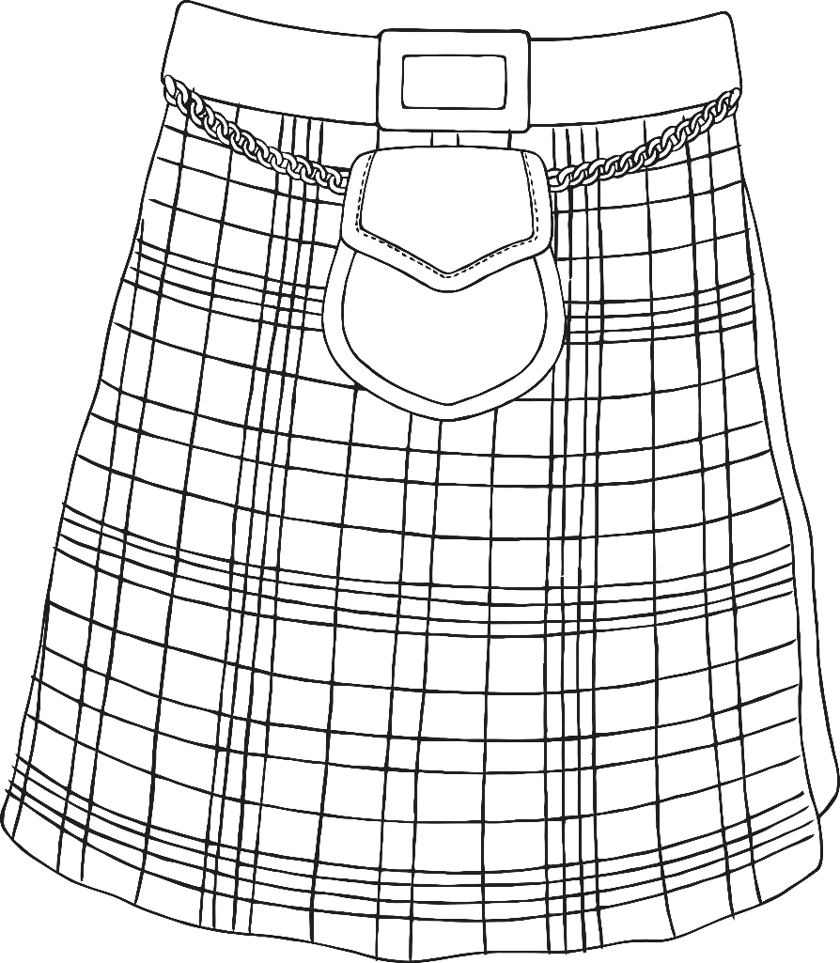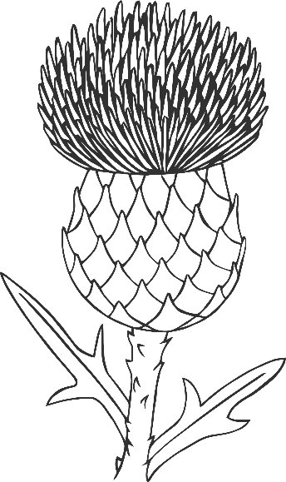

© 2024 Little Owls Resources

The Selkirk Grace

Some hae meat and canna eat.

And some wad eat that want it,

But we hae meat and we can eat,

Sae let the Lord be thankit!



© 2024 Little Owls Resources

The Selkirk Grace

Some hae meat and canna eat.

And some wad eat that want it,

But we hae meat and we can eat,

Sae let the Lord be thankit!

