© 2024 Little Owls Resources

Some hae meat and canna eat. And some wad eat that want it. But we hae meat and we can eat, sae let the Lord be thankit!

The Selkirk Grace

Illustration Activity

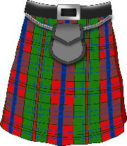

© 2024 Little Owls Resources

Some hae meat and canna eat. And some wad eat that want it. But we hae meat and we can eat, sae let the Lord be thankit!

The Selkirk Grace

Illustration Activity