**All About Me**

Self-Portrait Display – Bunting

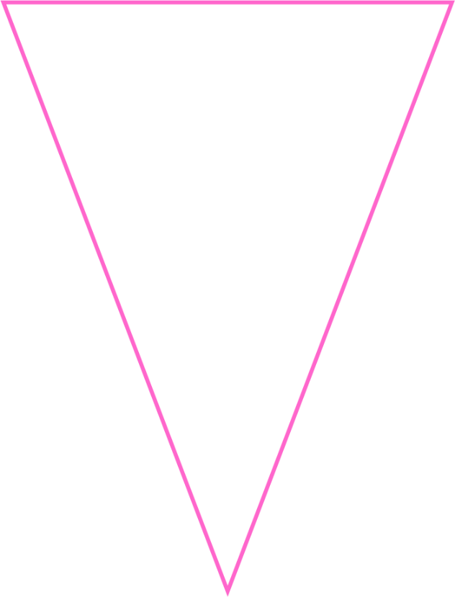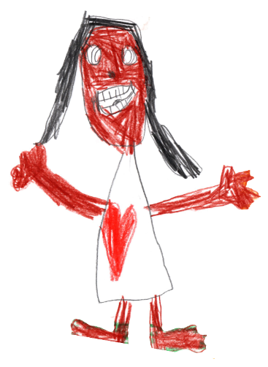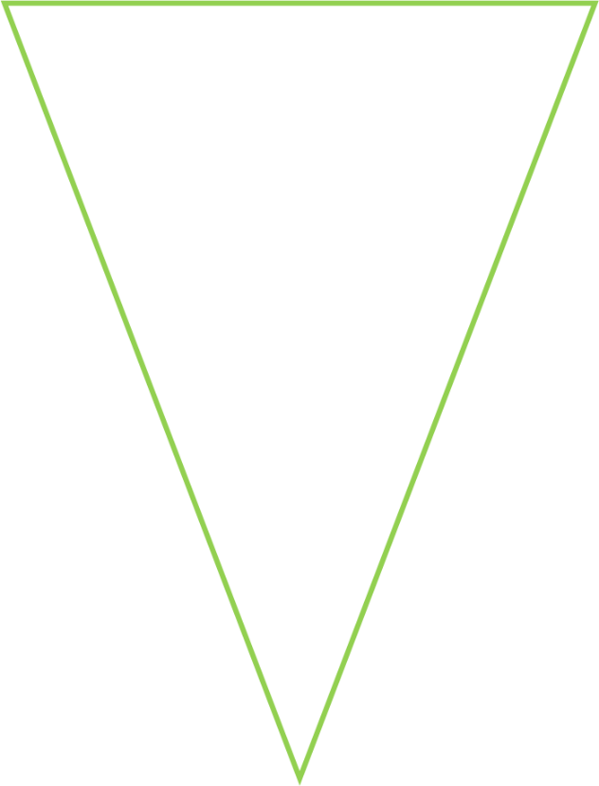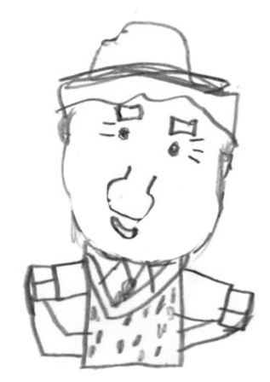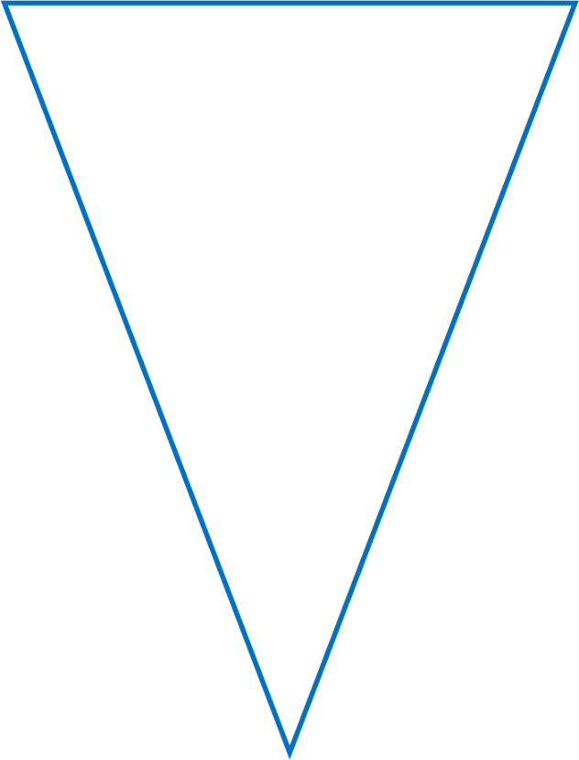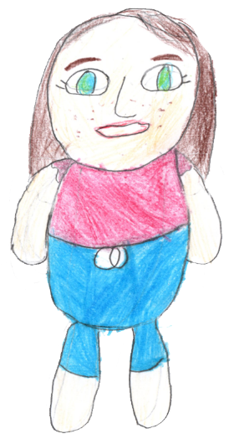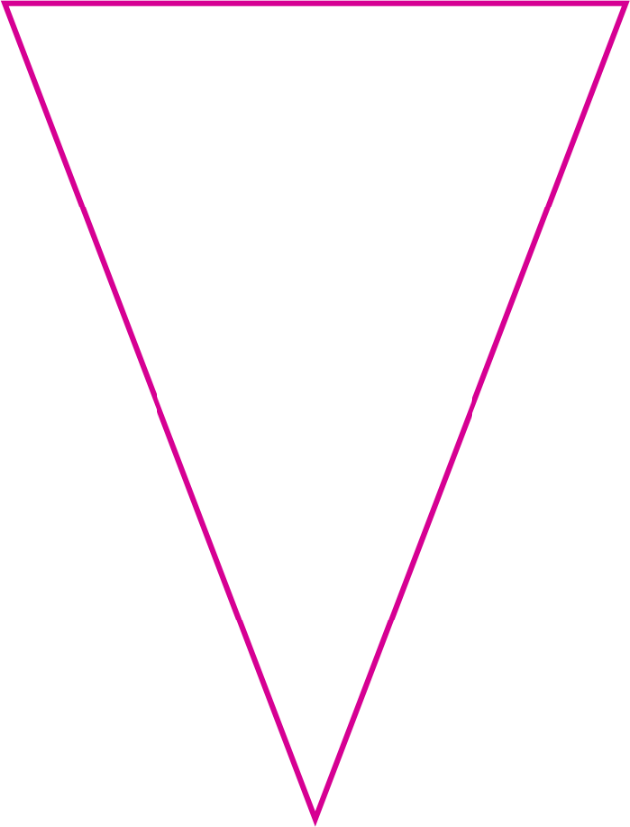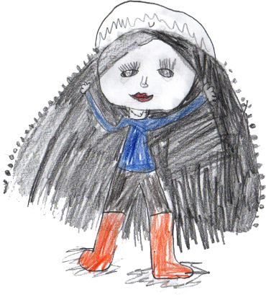

© 2021 Little Owls Resources

Children can choose the colour outline they would like to use, then draw a self-portrait that can be used to create a larger display of them all!

© 2021 Little Owls Resources

© 2021 Little Owls Resources

© 2021 Little Owls Resources

© 2021 Little Owls Resources

© 2021 Little Owls Resources

© 2021 Little Owls Resources

© 2021 Little Owls Resources

© 2021 Little Owls Resources

© 2021 Little Owls Resources