**Sea Lion**

The pages of this pack give some general information about sea lions and some fun and engaging activities to foster and develop children’s interest in them.

**This pack includes:**

* Fact posters x3 (Could be used as stimuli for a lesson input)
* Number slice activity (1-10) (Can be pre-cut for a pure number ordering activity or left to be cut by child to add scissor practice)
* Number slice activity - colouring version (1-10) (As above but to be coloured before cutting)
* Description sheet (Can be used as an independent writing activity or with an adult scribing the ideas of a younger child)
* A4 poster
* A4 poster - colouring version
* ‘Body Parts’ x3 (fully labelled, initial sounds only, blank)
* Draw and write sheets x3 (blank sheet, wide lines and narrow lines)
* 1x 4-piece puzzle
* Multimats x2 (for Colouring/Art & Craft/Loose Parts/Playdough)

© 2021 Little Owls Resources

This pack includes:

The pages of this pack give some general information about the role of a paramedic and some fun and engaging activities to foster and develop children’s interest in this role in society.

© 2021 Little Owls Resources

**Sea Lion Facts**

Sea lions can live for

years.

**30**

Sea lions eat **fish**.

Sea lions are distant relations to dogs and foxes.

**Sea Lions are** Endangered.

Climate change has changed the waters in which sea lions live.

In the past, humans hunted and killed many sea lions.

This means there is a very high risk that they may become extinct.

© 2021 Little Owls Resources

**How big is a Sea Lion?**



200cm / 2m

© 2021 Little Owls Resources

1

2

3

4

5

6

7

8

9

10

© 2021 Little Owls Resources

© 2021 Little Owls Resources

1

2

3

4

5

6

7

8

9

10

© 2021 Little Owls Resources

**What words would you use to describe a sea lion?**

**Sea Lion**

© 2021 Little Owls Resources

**Sea Lion**

© 2021 Little Owls Resources

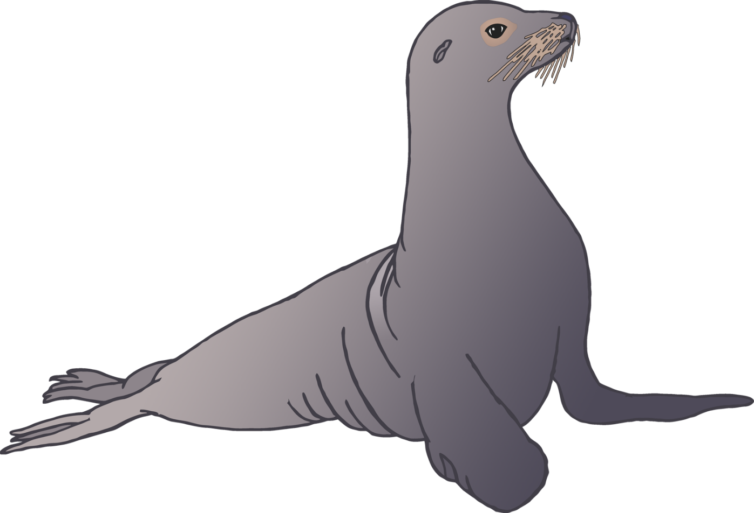

**Sea lion body parts**

© 2021 Little Owls Resources

fur

nose

eye

flippers

**w**hisker



**Sea lion body parts**

© 2021 Little Owls Resources

f

n

e

f

**w**



**Sea lion body parts**

© 2021 Little Owls Resources

© 2021 Little Owls Resources

**Draw a Sea Lion!**

© 2021 Little Owls Resources

**Draw and write about a Sea Lion!**

____________________________________________________

© 2021 Little Owls Resources

**Draw and write about a Sea Lion!**

______________________________________________________________________________________________________

**Sea Lion**

© 2021 Little Owls Resources

© 2021 Little Owls Resources

**Sea Lion Multimat – Sea Lion**

© 2021 Little Owls Resources

**Sea Lion Multimat – Sea Lion and Fish**

