www.littleowls-premium.com

Crab

Dolphin

Eel

© 2020 Little Owls Resources

www.littleowls-premium.com

© 2020 Little Owls Resources

www.littleowls-premium.com

© 2020 Little Owls Resources

© 2020 Little Owls Resources

www.littleowls-premium.com

© 2020 Little Owls Resources

www.littleowls-premium.com

© 2020 Little Owls Resources

www.littleowls-premium.com

Octopus

Fish

Jellyfish

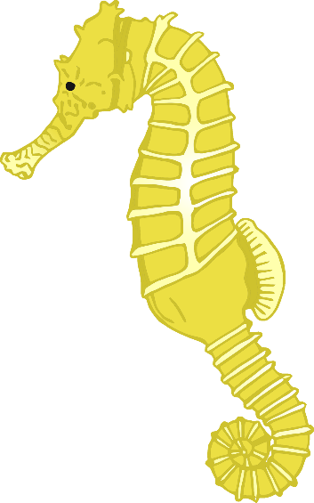

© 2020 Little Owls Resources

www.littleowls-premium.com

© 2020 Little Owls Resources

www.littleowls-premium.com

© 2020 Little Owls Resources

www.littleowls-premium.com

Sea Lion

Seahorse

Starfish

www.littleowls-premium.com

© 2020 Little Owls Resources

Turtle

Narwhal

www.littleowls-premium.com

© 2020 Little Owls Resources

www.littleowls-premium.com

crab

dolphin

eel

© 2020 Little Owls Resources

www.littleowls-premium.com

esources.com

© 2020 Little Owls Resources

www.littleowls-premium.com

© 2020 Little Owls Resources

© 2020 Little Owls Resources

www.littleowls-premium.com

© 2020 Little Owls Resources

www.littleowls-premium.com

© 2020 Little Owls Resources

www.littleowls-premium.com

octopus

fish

jellyfish



© 2020 Little Owls Resources

www.littleowls-premium.com

© 2020 Little Owls Resources

www.littleowls-premium.com

© 2020 Little Owls Resources

www.littleowls-premium.com

sea lion

seahorse

starfish

www.littleowls-premium.com

.com

© 2020 Little Owls Resources

turtle

narwhal

www.littleowls-premium.com

© 2020 Little Owls Resources