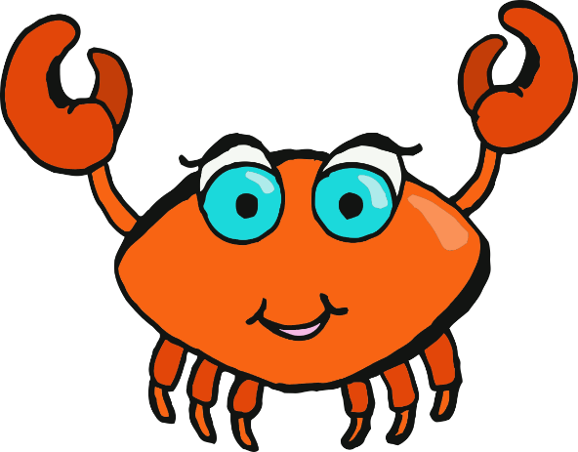

www.littleowlsresources.com

Crab

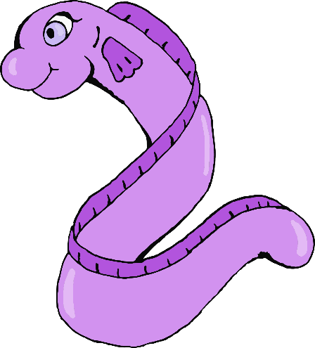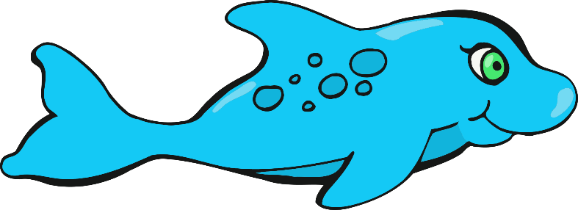

Dolphin

Eel

© 2019 Little Owls Resources

www.littleowlsresources.com

© 2019 Little Owls Resources

www.littleowlsresources.com

© 2019 Little Owls Resources

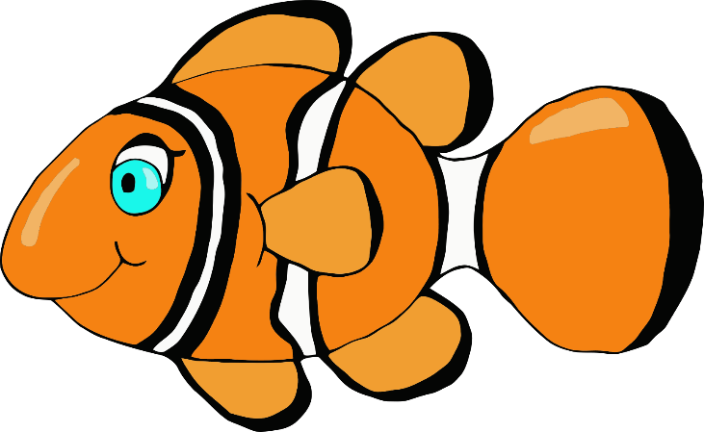

© 2019 Little Owls Resources

www.littleowlsresources.com

© 2019 Little Owls Resources

www.littleowlsresources.com

© 2019 Little Owls Resources

www.littleowlsresources.com

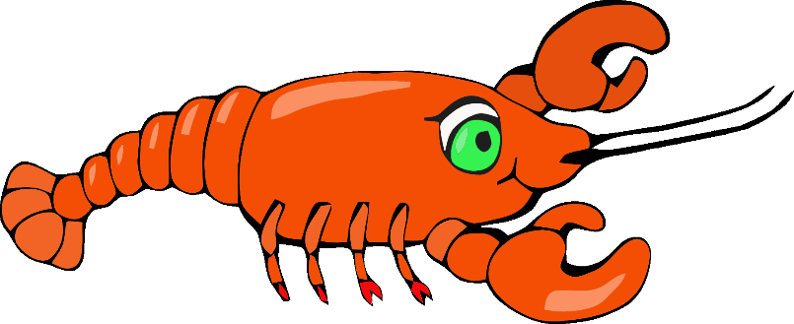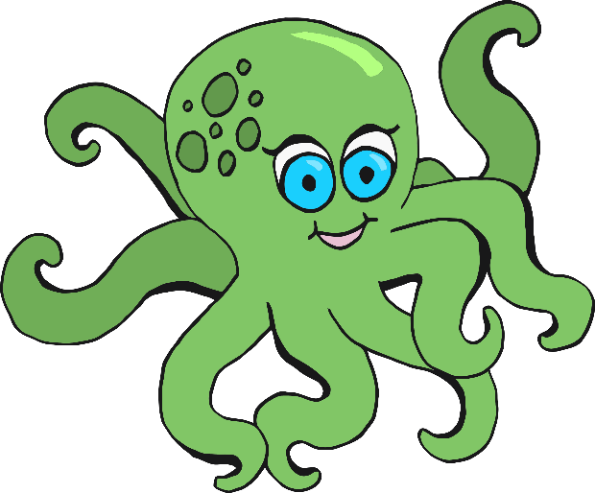

Octopus

Fish

Lobster



© 2019 Little Owls Resources

www.littleowlsresources.com

© 2019 Little Owls Resources

www.littleowlsresources.com

© 2019 Little Owls Resources

www.littleowlsresources.com

Sea Lion

Seahorse

Starfish

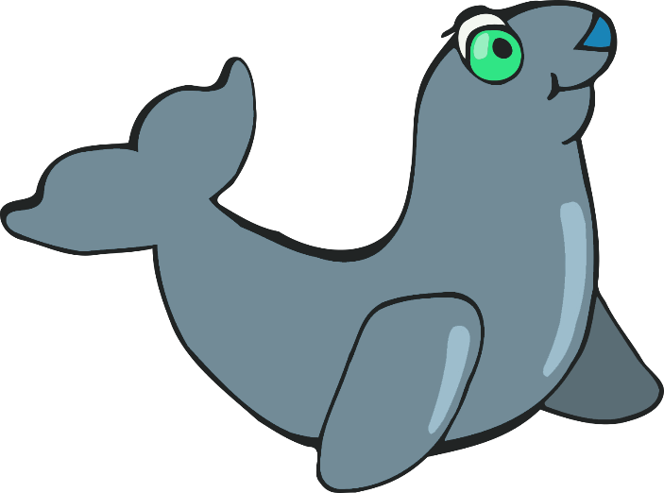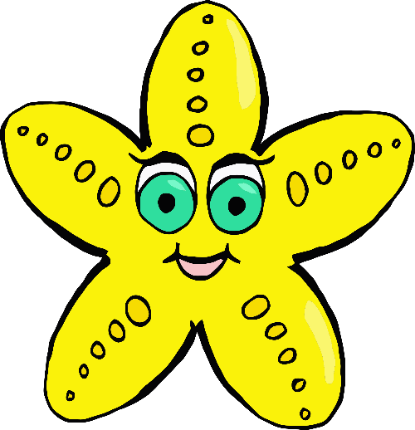

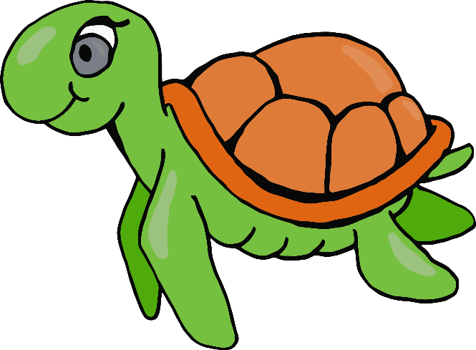

www.littleowlsresources.com

© 2019 Little Owls Resources

Turtle



www.littleowlsresources.com

crab



dolphin

eel

© 2019 Little Owls Resources

www.littleowlsresources.com

© 2019 Little Owls Resources

www.littleowlsresources.com

© 2019 Little Owls Resources



© 2019 Little Owls Resources

www.littleowlsresources.com

© 2019 Little Owls Resources

www.littleowlsresources.com

© 2019 Little Owls Resources

www.littleowlsresources.com



octopus

fish

lobster



© 2019 Little Owls Resources

www.littleowlsresources.com

© 2019 Little Owls Resources

www.littleowlsresources.com

© 2019 Little Owls Resources

www.littleowlsresources.com

sea lion

seahorse

starfish





www.littleowlsresources.com

© 2019 Little Owls Resources

turtle