**Sea Animals Word Mat**

© 2020 Little Owls Resources

jellyfish

turtle

fish

crab

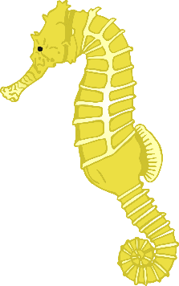

sea lion

seahorse

starfish

octopus

conger eel

narwhal

dolphin