

www.littleowlsresources.com

www.littleowlsresources.com

© 2020 Little Owls Resources

© 2020 Little Owls Resources

0

1

1

1

1

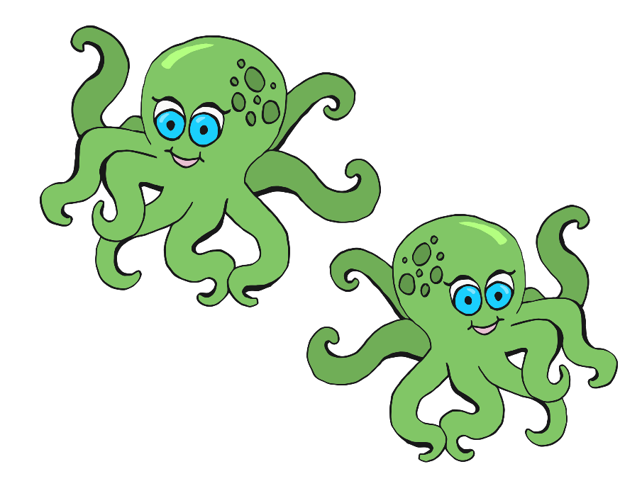

© 2020 Little Owls Resources

www.littleowlsresources.com

© 2020 Little Owls Resources

www.littleowlsresources.com

0

2

2

2

2

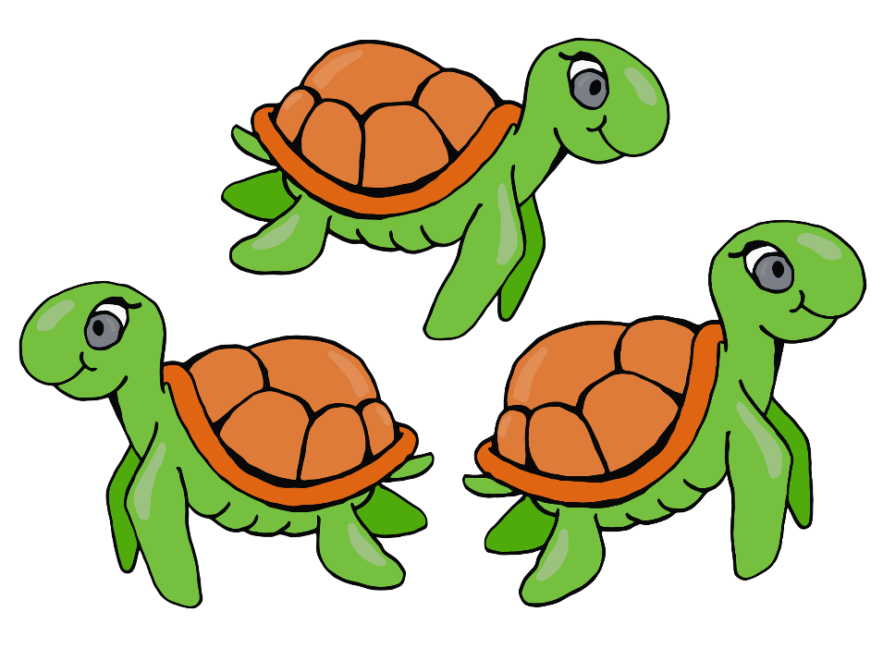

© 2020 Little Owls Resources

www.littleowlsresources.com

© 2020 Little Owls Resources

www.littleowlsresources.com

0

3

3

3

3

© 2020 Little Owls Resources

www.littleowlsresources.com

© 2020 Little Owls Resources

www.littleowlsresources.com

0

4

4

4

4

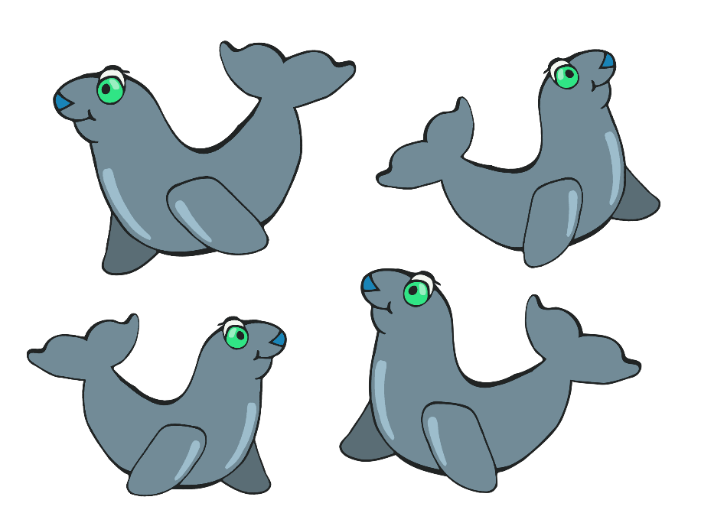

www.littleowlsresources.com

5

5

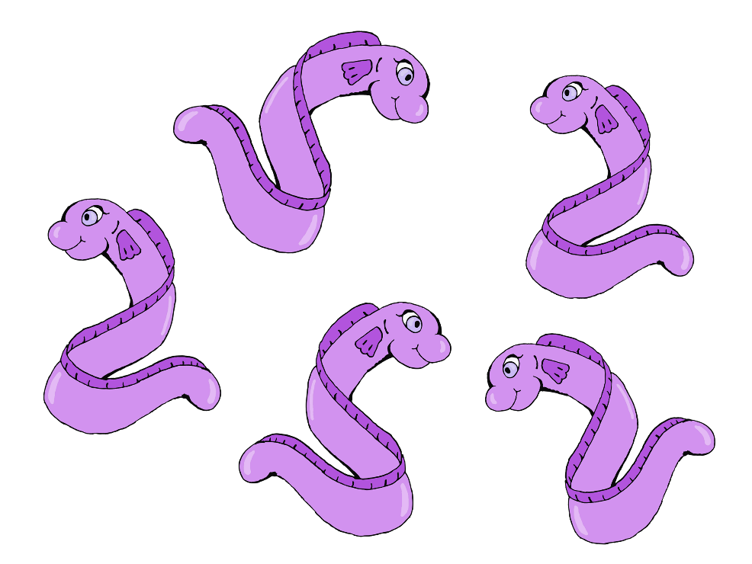

5

5

© 2020 Little Owls Resources

www.littleowlsresources.com

0

© 2020 Little Owls Resources

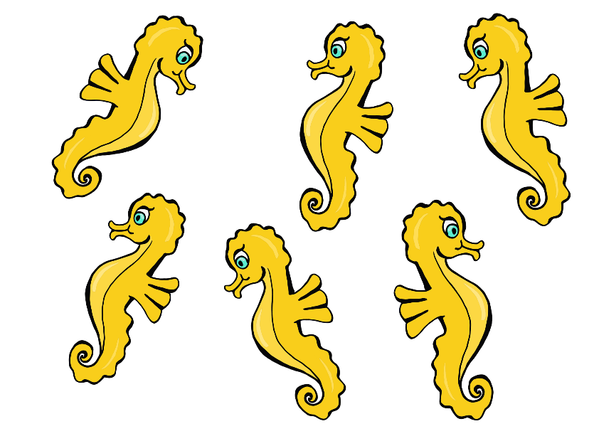

© 2020 Little Owls Resources

www.littleowlsresources.com

© 2020 Little Owls Resources

www.littleowlsresources.com

0

6

6

6

6

www.littleowlsresources.com

7

7

7

7

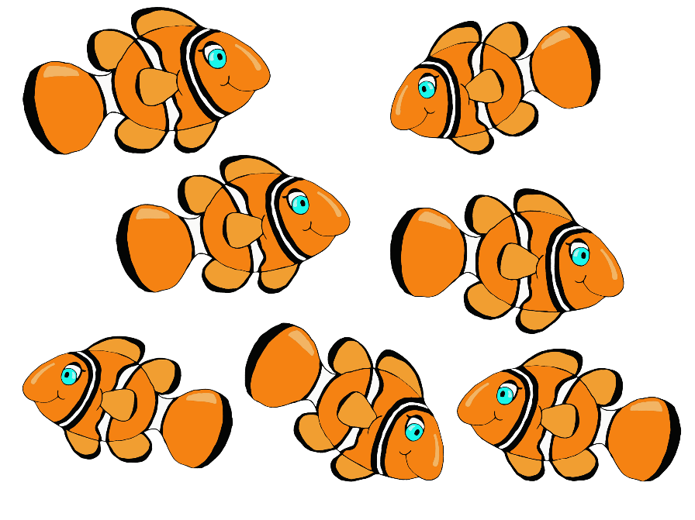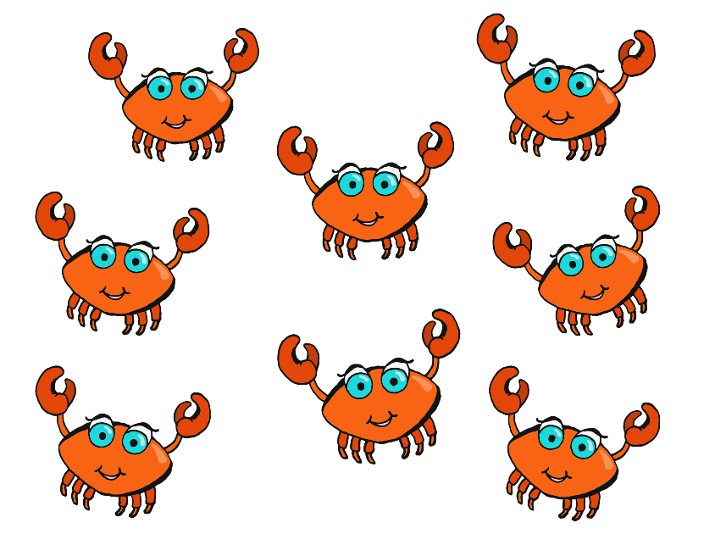

© 2020 Little Owls Resources

© 2020 Little Owls Resources

www.littleowlsresources.com

0

© 2020 Little Owls Resources

www.littleowlsresources.com

0

© 2020 Little Owls Resources

www.littleowlsresources.com

8

8

8

8

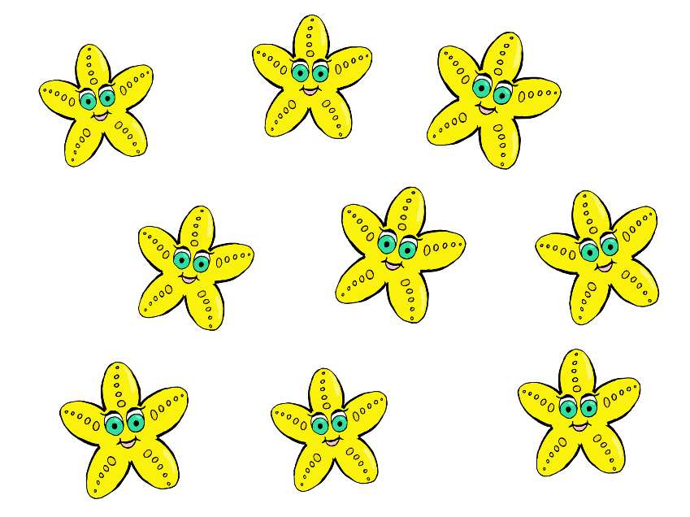

© 2020 Little Owls Resources

www.littleowlsresources.com

© 2020 Little Owls Resources

www.littleowlsresources.com

0

9

9

9

9

© 2020 Little Owls Resources

www.littleowlsresources.com

© 2020 Little Owls Resources

www.littleowlsresources.com

0

10

10

10

10

