www.littleowls-premium.com

© 2020 Little Owls Resources

* Can live for more than 40 years.
* Loves eating fish and squid.
* Breathes air just like us!
* Very clever; loves to play and learn.

Clownfish

* Can live for up to 80 years.
* Loves eating sea grass and algae.
* Can hold its breath for 5 hours!
* Goes to sleep underwater!

Sea Turtle

Bottlenose Dolphin

© 2020 Little Owls Resources

www.littleowls-premium.com

www.littleowls-premium.com

© 2020 Little Owls Resources

* Can live for 6 years.
* Loves eating algae and worms.
* Lives in anemones. The clownfish is immune to the anemone sting so it hides there for safety and keeps fish that like to eat anemones away.

© 2020 Little Owls Resources

www.littleowls-premium.com

© 2020 Little Owls Resources

www.littleowls-premium.com

© 2020 Little Owls Resources

www.littleowls-premium.com

* Can live up to 5 years.
* Loves eating crabs and shellfish
* Can change its colour to hide.
* They can taste with their tentacles.

Common Starfish

Yellow Seahorse

Common Octopus

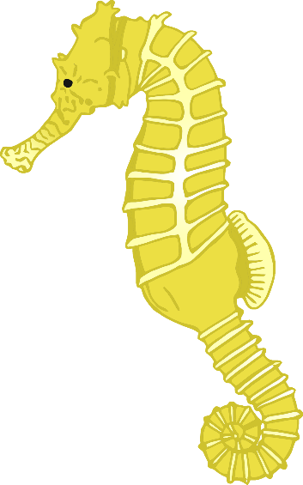

* Can live for up to 5 years.
* Loves eating shrimp.
* Grows up to 30cm.
* The male seahorse looks after seahorse eggs until they are ready to hatch.
* Can live for 8 years.
* Loves eating molluscs and barnacles.
* Grows up to 30cm.
* Can regrow a lost limb.

www.littleowls-premium.com

© 2020 Little Owls Resources

www.littleowls-premium.com

© 2020 Little Owls Resources

www.littleowls-premium.com

© 2020 Little Owls Resources

* Only lives for 6 months
* Grow to 40cm diameter
* Eats small fish, crustaceans worms and other jellyfish.

Sea Nettle Jellyfish

* Can live for up to 20 years.
* Loves eating shellfish.
* Sleeps in the day. (Nocturnal)
* Its blood is blue!

Crab

California Sea Lion

* Can live up to 30 years.
* Loves eating fish and squid.
* Breathes air just like us!
* Loves being with other Sea Lions!

www.littleowls-premium.com

© 2020 Little Owls Resources

* Can live for up to 40 years.
* Grows up to 5m long.
* Loves to eat squid, fish, shrimp, and crab
* The tusk is an enlarged tooth.

Narwhal

www.littleowls-premium.com

© 2020 Little Owls Resources

Conger Eel

* Can live for up to 15 years.
* Grows up to 3m long.
* Loves to eat fish.
* Sometimes live in old shipwrecks.