Largest city in Scotland:

Glasgow

Scotland’s capital city:

Edinburgh

The population of Scotland is approximately 5.4 million.

5,400,000

people

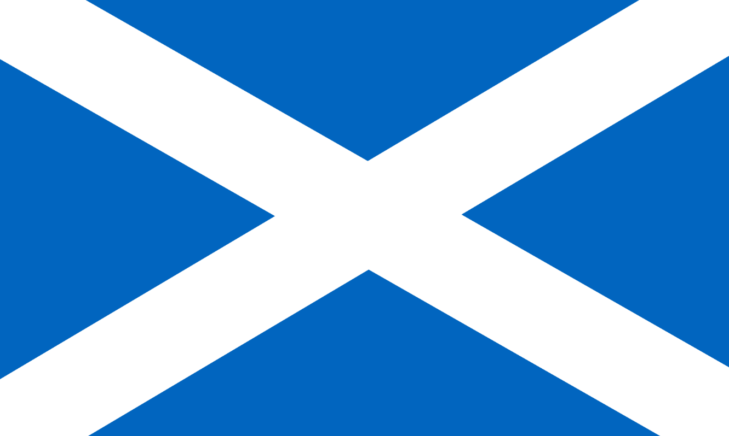

© 2019 Little Owls Resources



© 2019 Little Owls Resources

Scotland part of Great Britain for over

300

years

People have been living in Scotland for

12,000

years



© 2019 Little Owls Resources



© 2019 Little Owls Resources

Scottish Discovery

Alexander Fleming discovered

Penicillin

(A VERY important type of medicine)



© 2019 Little Owls Resources



© 2019 Little Owls Resources

Scottish Invention

Alexander Graham Bell invented the

Telephone

Scottish Invention

Kirkpatrick Macmillan & Thomas McCall invented the

Bicycle

Scottish Invention

John Logie Baird invented the

Television



**© 2019 Little Owls Resources**



**© 2019 Little Owls Resources**



**© 2019 Little Owls Resources**



**© 2019 Little Owls Resources**