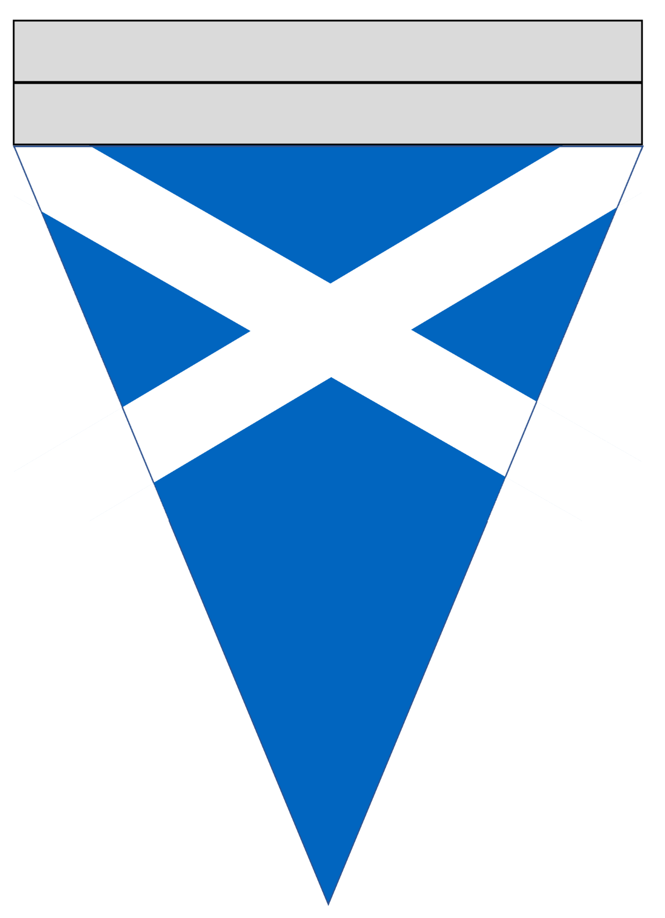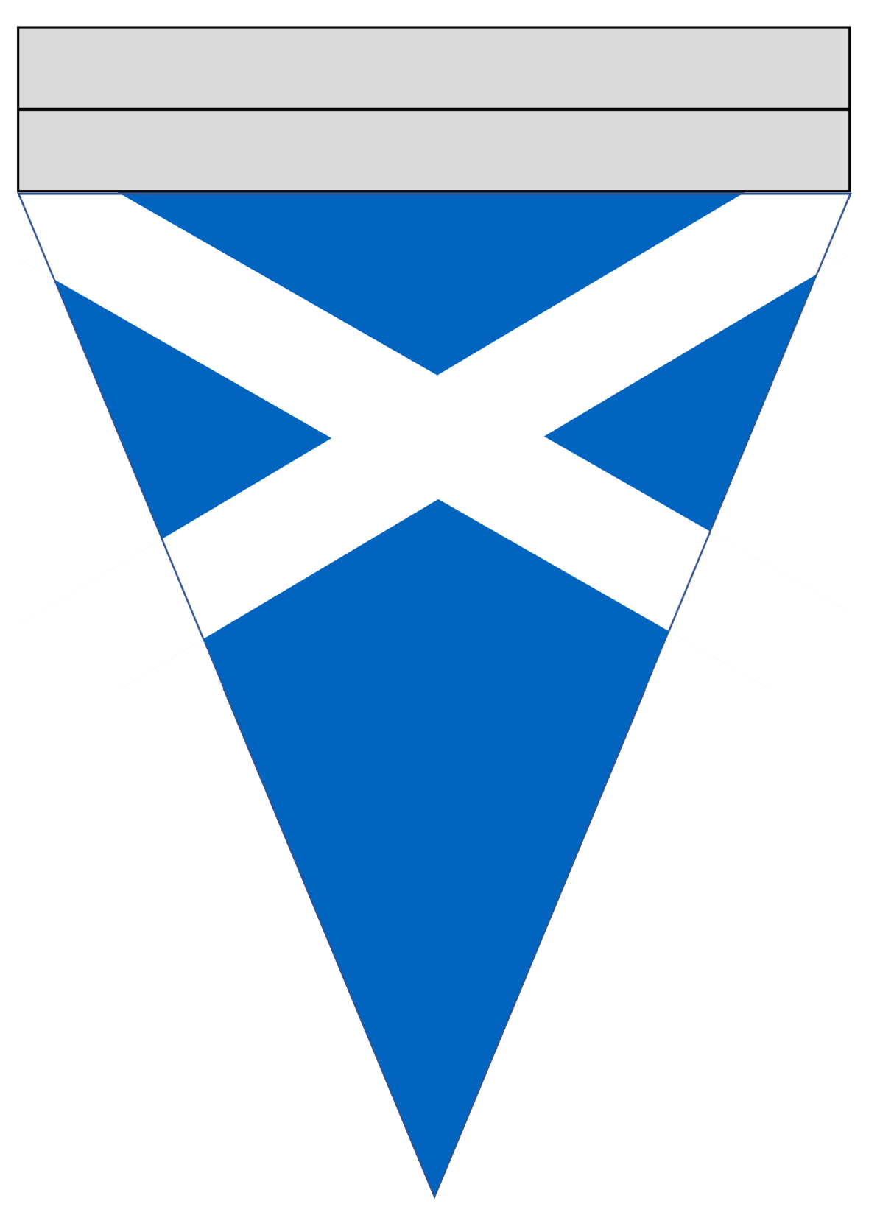

© 2019 Little Owls Resources

c

© 2019 Little Owls Resources

c

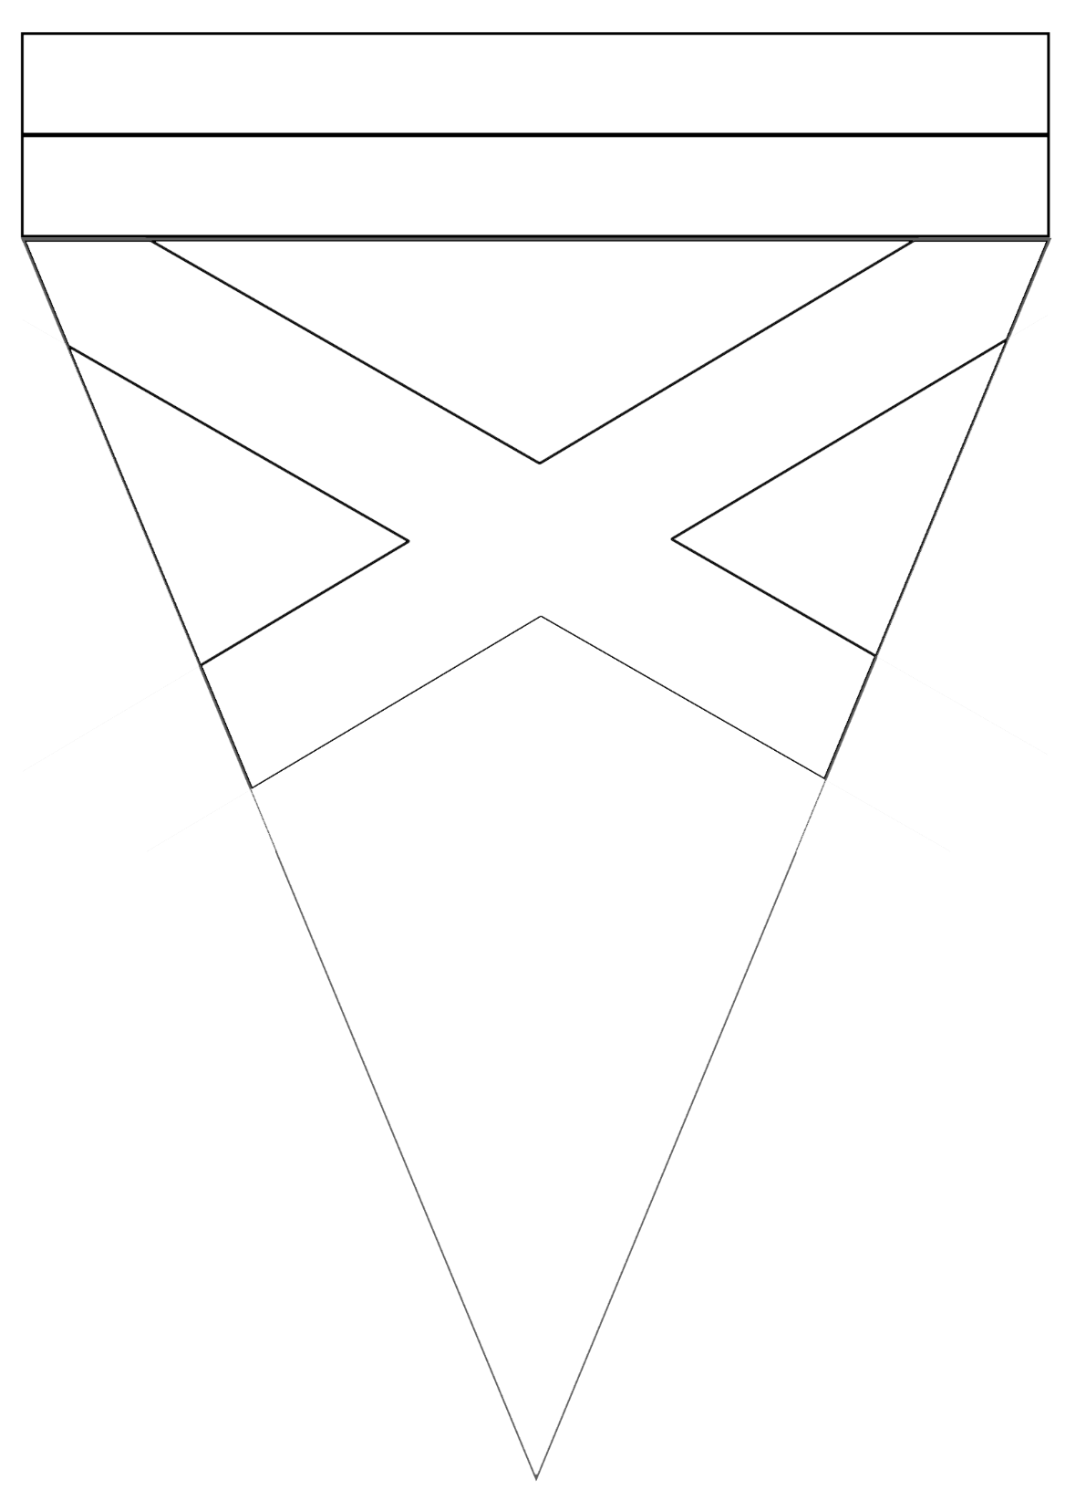

© 2019 Little Owls Resources

c

© 2019 Little Owls Resources

c