**Save the Penguins!**

Keep Plastic out of the Ocean!

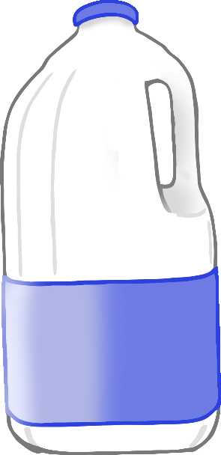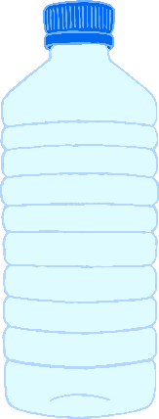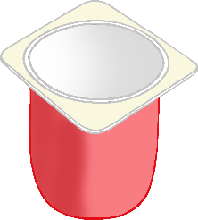

© 2021 Little Owls Resources

© 2021 Little Owls Resources

**Keep Plastic out of the Ocean!**

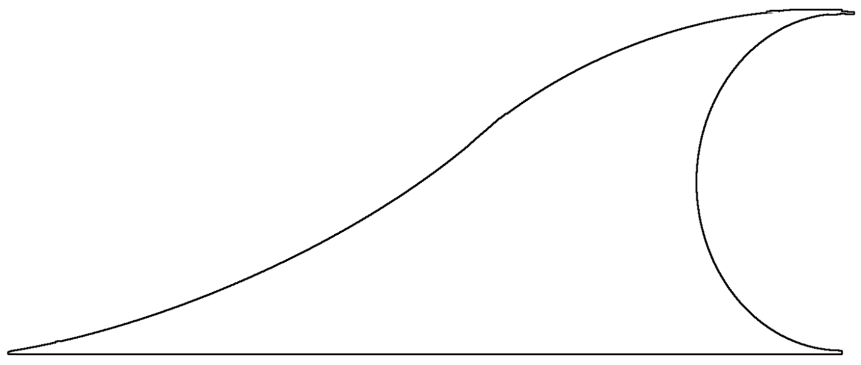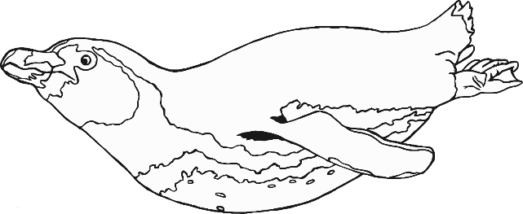

**Save the Penguins!**

