Sand Play

Sand Treasure Map

These maps have blank centres for children to draw the sand tray and mark where they have hidden their treasure. They can then challenge a friend to find the treasure using the map to guide them!

© 2021 Little Owls Resources

© 2020 Little Owls Resources

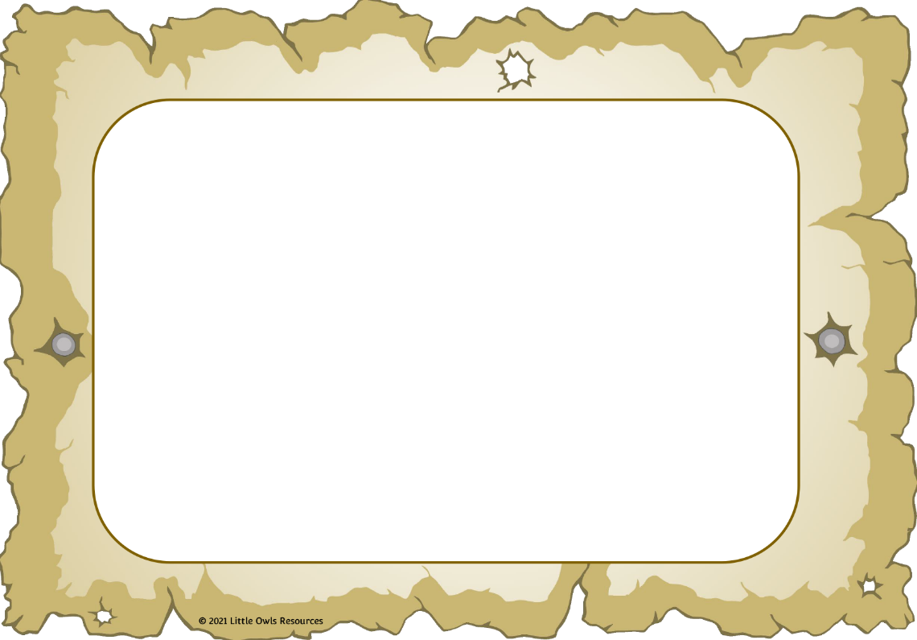

x

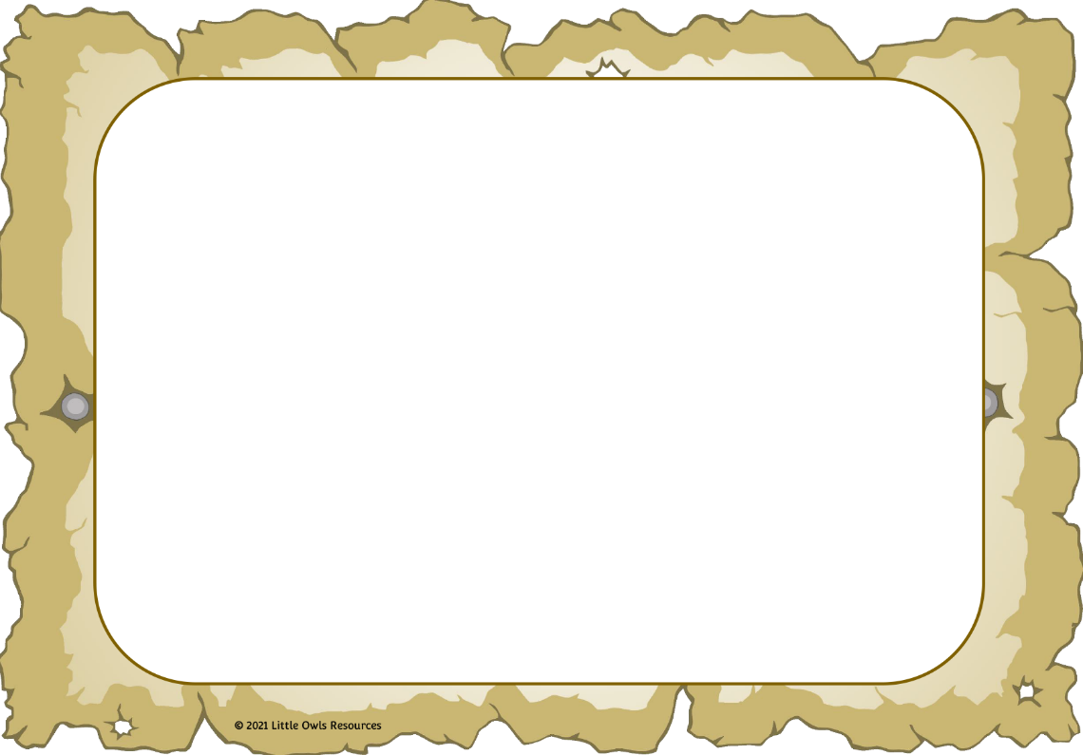

x

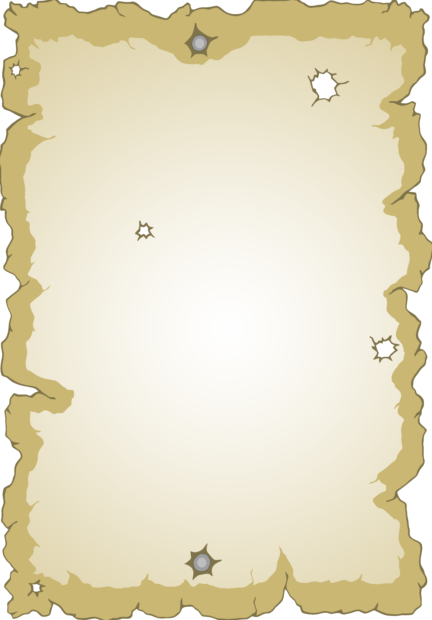

© 2021 Little Owls Resources



© 2021 Little Owls Resources