STEM

**Winter challenge cards (sample)**

These cards are to be used as prompts for a winter themed STEM session.

(Science Technology Engineering and Mathematics)

The challenges are intended to be open ended and non-specific to encourage independent thinking in the children.

Fold along this line and laminate

© 2022 Little Owls Resources

© 2022 Little Owls Resources

STEM

Can you…

**…melt ice**?

**Winter challenge**

© 2022 Little Owls Resources

STEM

**Questions**

Was your ice found outside on a very cold day or was it created in a freezer?

How long did it take you to melt your ice?

Do you think you could melt it any quicker next time? What could you change to speed it up?

?

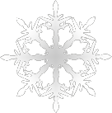

© 2022 Little Owls Resources

STEM

Can you…

**…investigate plants in the wintertime**?

**Winter challenge**

© 2022 Little Owls Resources

STEM

**Questions**

What plants grow in the winter months?

Can you find any plants in your garden, outdoor area, local park, or forest?

How are the winter plants different from plants growing in the warmer months?

?





© 2022 Little Owls Resources

STEM

Can you…

**…make a paper snowflake**?

**Winter challenge**

© 2022 Little Owls Resources

STEM

**Questions**

How can you make a paper snowflake? Ask an adult to help you.

What shapes do you see in your snowflake?

?

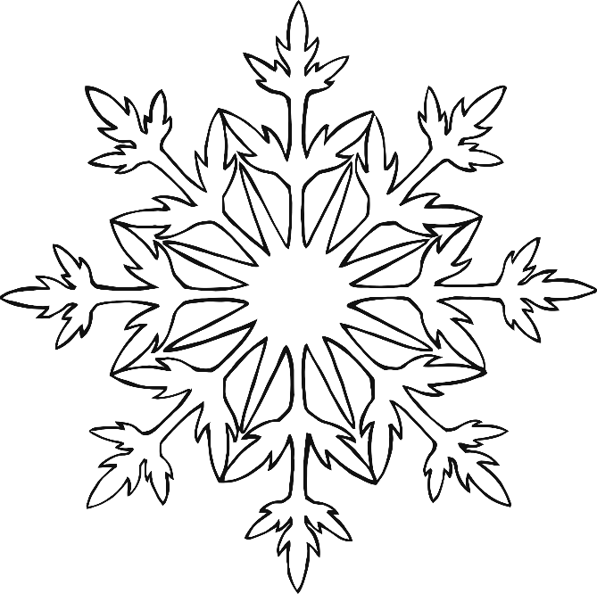

© 2022 Little Owls Resources

STEM

Can you…

**Winter challenge**

© 2022 Little Owls Resources

STEM

**Questions**

?

