STEM

Challenge support materials

p2: Challenge/Questions card

p3-5: Posters

p6: Practitioner notes

p7-12: Word cards (&blanks) (for display or as flash cards)

p13-15: ‘What did we do?’ sheets (for writing, drawing, or adding a photograph)

p16-18: ‘My instrument’ sheets (for writing, drawing, or adding a photograph)

**Make a musical instrument**

**This pack includes…**

© 2022 Little Owls Resources

© 2022 Little Owls Resources

STEM

Can you…

…make a musical instrument?

Challenge

© 2022 Little Owls Resources

STEM

Questions

Can you make an instrument that you tap?

Can you make an instrument that you shake?

Can you play your instrument loudly?

Can you play your instrument quietly?

?

?

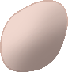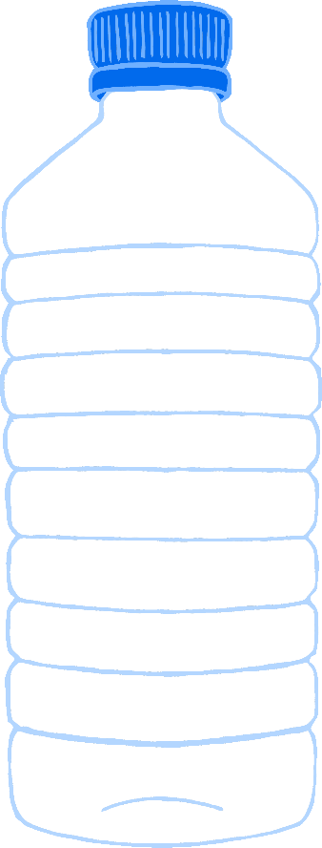

?

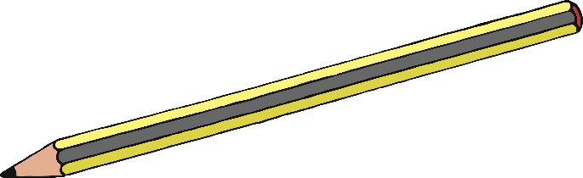

Make an instrument you can tap or scrape!

© 2022 Little Owls Resources

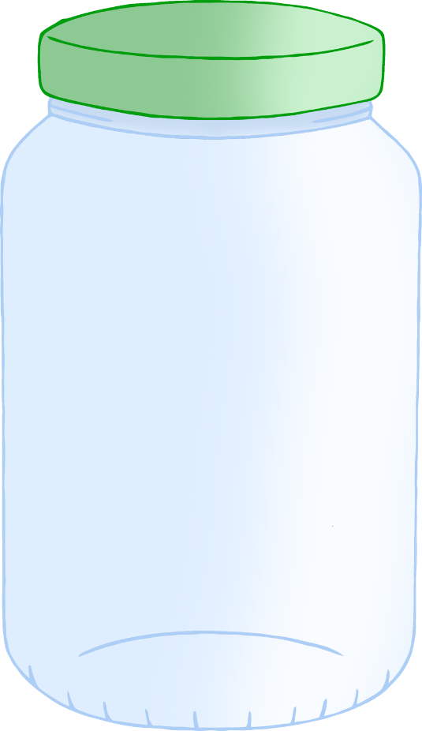

Make an instrument you can pluck!

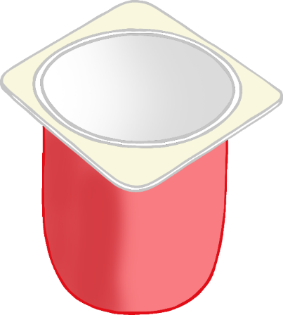

© 2022 Little Owls Resources

Make an instrument you can shake!

Shadows

© 2022 Little Owls Resources

Encourage a short discussion about what types of musical instrument there are, ideally looking at some real ones.

How is the sound made on each one?

Give the children time to explore their ideas about making an instrument before seeing the gathered materials.

How will you make it? - What do you need?

Allow the children to create their instruments with as much independence as possible. Give them the chance to see and correct mistakes themselves.

How well did your instrument work?

How could you make it better?

* plastic bottles, yoghurt ports, empty plastic containers, etc.
* small stones, lentils, small pasta, etc
* a selection of old pots and pans
* wooden spoons
* sticks
* sticky tape/masking tape
* elastic bands
* a selection of musical instruments

© 2022 Little Owls Resources

**Items that might be useful**

STEM

**Make a musical instrument**

Practitioner notes

shake

sound

© 2022 Little Owls Resources

© 2022 Little Owls Resources

© 2022 Little Owls Resources

tap

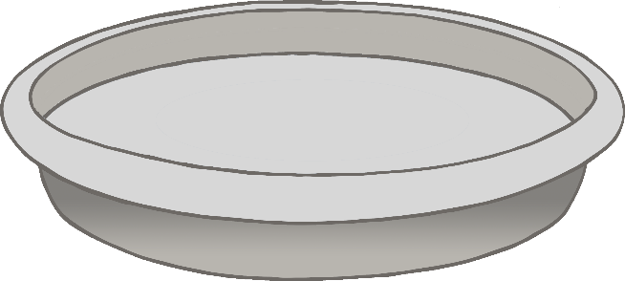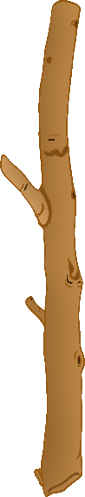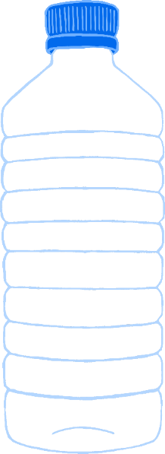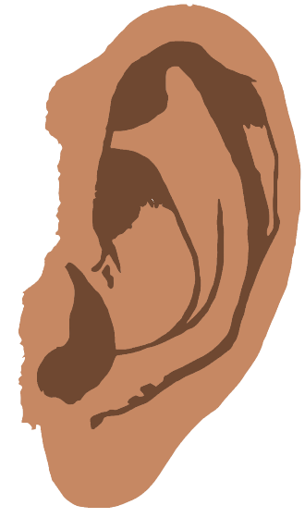

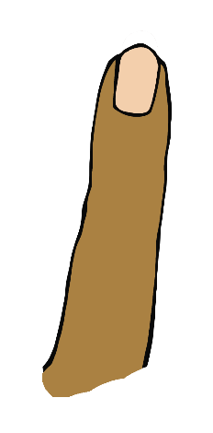



scrape

pluck

© 2022 Little Owls Resources

© 2022 Little Owls Resources

© 2022 Little Owls Resources

music

beat

© 2022 Little Owls Resources

© 2022 Little Owls Resources

© 2022 Little Owls Resources



blow

music

rhythm

beat

© 2022 Little Owls Resources

© 2022 Little Owls Resources

© 2022 Little Owls Resources



long

short

duration

duration

© 2022 Little Owls Resources

© 2022 Little Owls Resources

© 2022 Little Owls Resources

high

pitch

low

loud

pitch

volume

volume

© 2022 Little Owls Resources

© 2022 Little Owls Resources

© 2022 Little Owls Resources

soft

© 2022 Little Owls Resources

© 2022 Little Owls Resources

© 2022 Little Owls Resources

__________________________________________________________________

© 2022 Little Owls Resources

**What did we do?**



**What did we do?**



____________________________

© 2022 Little Owls Resources

**What did we do?**



© 2022 Little Owls Resources

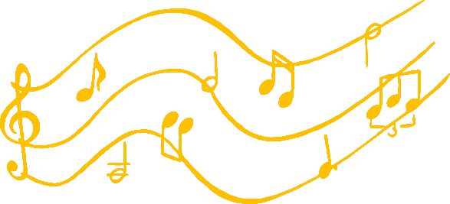

**My instrument**

__________________________________________________________________

© 2022 Little Owls Resources



**My instrument**

____________________________

© 2022 Little Owls Resources



**My instrument**

© 2022 Little Owls Resources