STEM

Challenge support materials

**Investigate minibeasts**

p2: Challenge/Questions card

p3-5: Posters

p6: Practitioner notes

p7-12: Word cards (&blanks) (for display or as flash cards)

p13-15: ‘What did we do?’ sheets (for writing, drawing, or adding a photograph)

p16-18: ‘Minibeasts’ sheets (for writing, drawing, or adding a photograph)

**This pack includes…**

© 2022 Little Owls Resources

© 2022 Little Owls Resources

STEM

Can you…

…investigate minibeasts outdoors?

Challenge

© 2022 Little Owls Resources

STEM

Questions

Can you find a minibeast?

How many legs does it have?

What is the minibeast doing?

How is it different from other minibeasts?

?

?

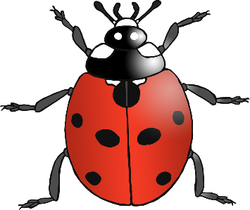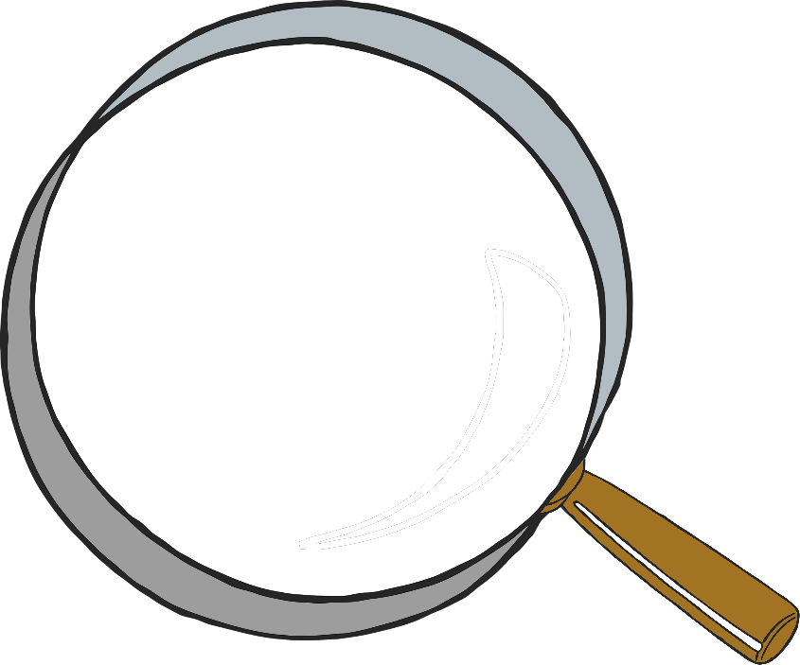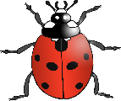

?

Bee body parts

wing

antenna

leg

© 2022 Little Owls Resources

stinger

eye

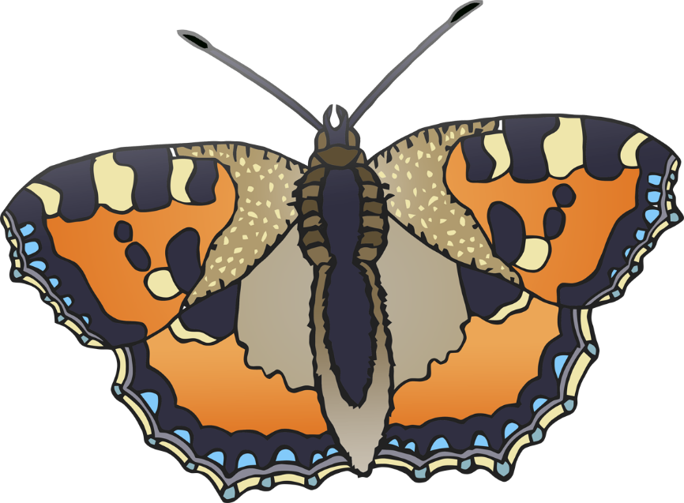

head

body

wing

antenna

© 2022 Little Owls Resources

Butterfly body parts

head

Ladybird body parts

Shadows

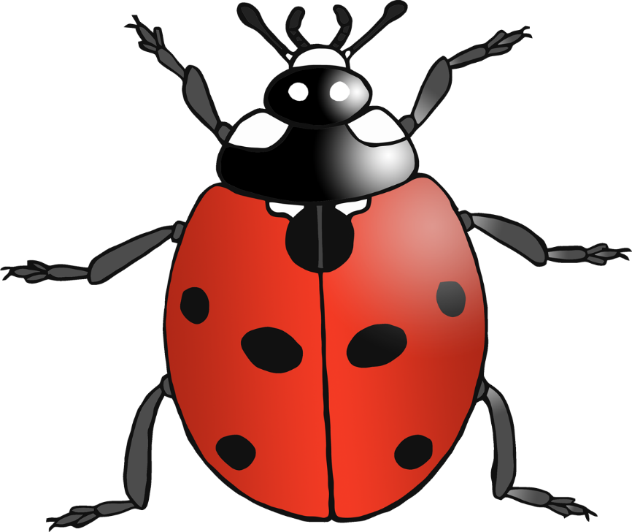

spot

antenna

leg

© 2022 Little Owls Resources

Practitioner notes

STEM

**Investigate minibeasts**

Encourage a short discussion about minibeasts.

What is a minibeast? – What minibeasts do you know?

Give the children time to explore their ideas.

How will you investigate minibeasts? – What equipment do you need?

Allow the children to observe and investigate with as much independence as possible. Let them enjoy their moments of discovery and encourage them to describe and comment on what they are seeing.

In what ways were the minibeasts you saw the same? – How were they different?

Remind the children about being careful with living creatures.

* Magnifying glass or equivalent
* Nets/Bug jars
* Outdoor area or prepared minibeast tray

**Items that might be useful**

© 2022 Little Owls Resources

dragonfly

snail

© 2022 Little Owls Resources

© 2022 Little Owls Resources

© 2022 Little Owls Resources

spider

worm

bee

caterpillar

© 2022 Little Owls Resources

© 2022 Little Owls Resources

© 2022 Little Owls Resources

fly

butterfly

ant

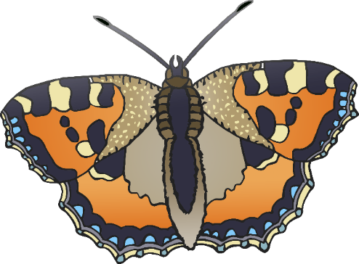

© 2022 Little Owls Resources

© 2022 Little Owls Resources

© 2022 Little Owls Resources

ladybird

woodlouse

centipede

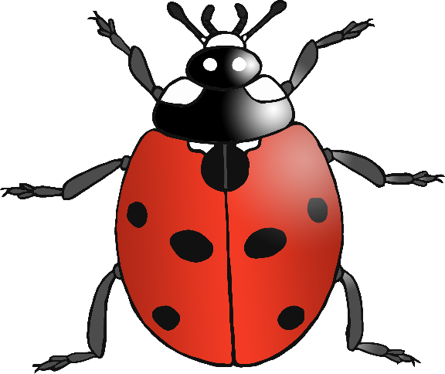

© 2022 Little Owls Resources

© 2022 Little Owls Resources

© 2022 Little Owls Resources

earwig

magnifying glass

minibeasts

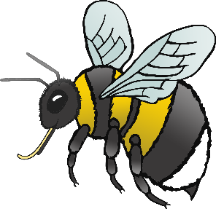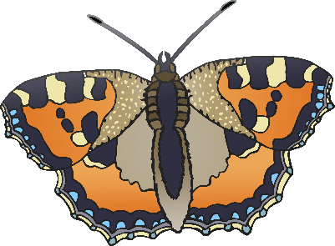

© 2022 Little Owls Resources

© 2022 Little Owls Resources

© 2022 Little Owls Resources

What did we do?

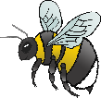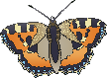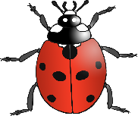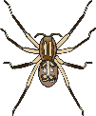

__________________________________________________________________

© 2022 Little Owls Resources

What did we do?



____________________________

© 2022 Little Owls Resources

What did we do?



© 2022 Little Owls Resources

__________________________________________________________________

Minibeasts

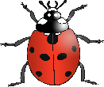

© 2022 Little Owls Resources

Minibeasts



____________________________

© 2022 Little Owls Resources

Minibeasts



© 2022 Little Owls Resources